|  |
| --- |
| Web Development |
| COS10005  Semester 2, 2025 |
|  |
|  |
|  |

|  |  |
| --- | --- |
| Member Name | Member ID |
| Perry Soon Le WONG | 104386144 |

|  |
| --- |
|  |

Table of Contents

Introduction 3

Website Content 4

General parts 4

Home page 6

Product pages 9

Workshop page 12

Promotion page 16

Workshop registration page 19

Enquiry page 23

Profile page 26

Enhancement page 28

Acknowledgement page 29

Site map 30

Website Style 31

General style 31

Home page 34

Product page 42

Workshop page 47

Promotion page 50

Workshop Registration and Enquiry form 53

Profile page 56

Enhancement page 58

Acknowledgement page 61

Key features 63

Dropdown menu 63

Sticky nav 65

Hover effect 66

Lightbox image 68

Flippable cards 72

Responsive hamburger menu 75

References 78

# Introduction

This website is dedicated to the Root Flowers, a florist based in Kuching, Sarawak, serving to display and promote the available products and services of the florist, while providing channels to facilitate customers-merchants connections. The website incorporates elegant greenery themes and interactive widgets, over several pages of different functionalities, with the aim to attract customers while providing information.

This report will demonstrate the architectures, details, designs, and enhancements of the created website in order to provide a deeper view into the inherent designs and codes of the website.

# Website Content

This section highlights the content and html structure in the .html files of the website.

## General Parts

The navigation bar and footer html structure is applied on all pages. The navigation bar provides links for users to navigate to different pages. The footer which includes the link to the florist’s Instagram page, WhatsApp number, and link to enhancement.html and acknowledgements.html.

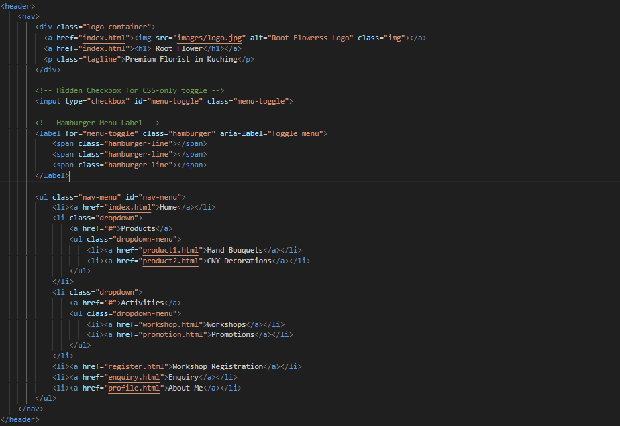

1

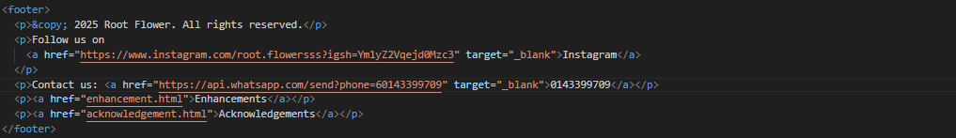

2

|  |  |
| --- | --- |
| No, | Description |
| 1 | Navigation bar   * Navigation bar with logo container. * Logo links to homepage. * Site name “Root Flower” and tagline. * Hidden checkbox for mobile menu toggle. * Hamburger menu with three span lines. * Unordered list for main navigation. * Links: Home, Products, Activities, Workshop, Enquiry, About Me. * Dropdowns: Hand Bouquets, CNY Decorations, Workshops, Promotions. * Layout: logo + tagline left, toggle right. |
| 2 | Footer   * © 2025 Root Flower. All rights reserved. * Instagram link opens in new tab. * WhatsApp contact link opens in new tab. * Link to enhancement.html. * Link to acknowledgements.html. |

## Home Page

The homepage’s main purpose is to introduce visitors to the florist’s services, showcase their floral creations, and provide quick access to different areas of the site. The content is organized into sections: a hero section with a welcoming message and call-to-action, a sidebar for quick navigation, a news section with updates about workshops and seasonal collections, a gallery displaying bouquets and festive arrangements, an events section highlighting upcoming workshops, a testimonials section sharing customer feedback, and a FAQ section answering common questions. The page ends with a footer that provides contact information, social media links, and references to enhancements and acknowledgements.

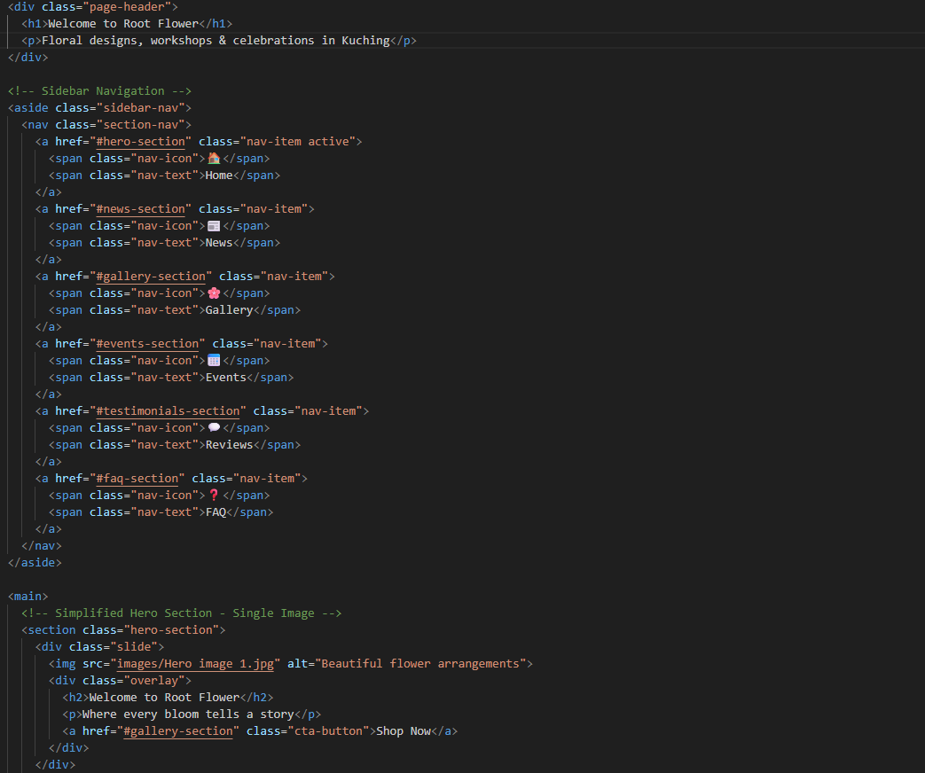

2

1

2

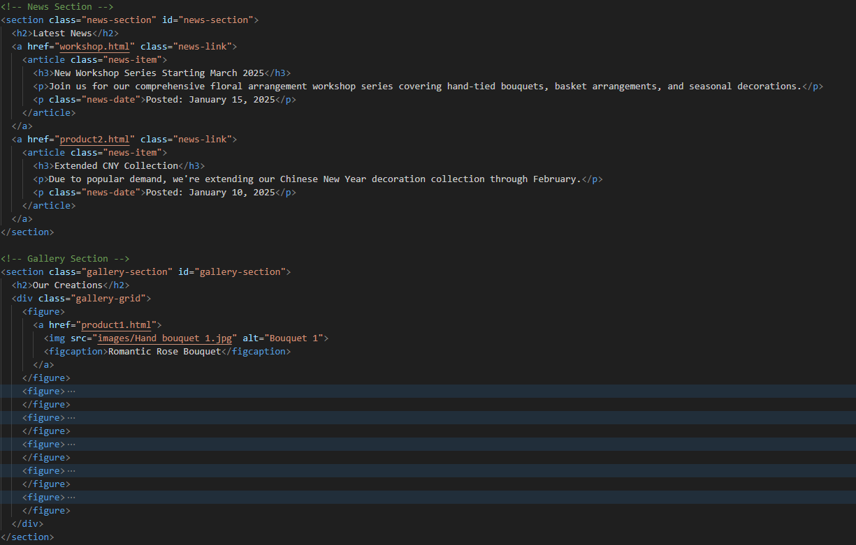

4

3

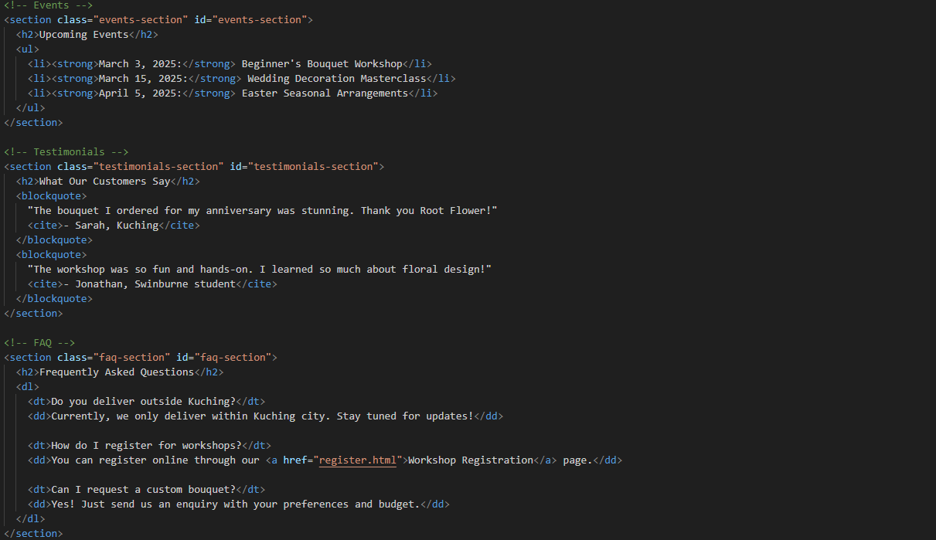

7

6

5

|  |  |
| --- | --- |
| No. | Description |
| 1 | Sidebar navigation   * nav class="section-nav" block. * Links include icon span and text span. * Navigates to Home, News, Gallery, Events, Reviews, FAQ. * Target sections have matching id attributes. |
| 2 | Hero section   * div class="page-header", section class="hero-section". * Header with main heading and short paragraph. * Hero slide contains main hero image. * Overlay with heading, paragraph, and gallery button. |
| 3 | News section   * Section element with class="news-section" and id="news-section" * Contains heading and two linked news articles * Each article wrapped inside a clickable link * Includes subheading (h3) and descriptive paragraph * • Ends with date paragraph using class "news-date" |
| 4 | Gallery section   * Section element with class="gallery-section" and id="gallery-section" * Contains heading and gallery grid (div class="gallery-grid") * Each figure holds link with image and caption |
| 5 | Events section   * Section element with class="events-section" and id="events-section" * Includes a heading and an unordered list (ul). * Each list item (li) features a bolded date (strong) followed by the event name. |
| 6 | Testimonials section   * Section element with class="testimonials-section" and id="testimonials-section" * Has a heading followed by two blockquotes. * Each includes customer feedback in quotes and a citation (cite) with name and place. |
| 7 | FAQ section   * Section element with class="faq-section" and id="faq-section" * Includes a heading and a description list (dl). * Each question (dt) has corresponding answer (dd). * One of the answers contains a link (a) to the registration page. |

## Product Pages

The product page showcases the florist’s hand bouquets with a clear, organized layout. The page begins with a prominent header featuring the main heading and a brief introductory description, immediately informing visitors of the page’s focus. The main content area highlights the product section, including a subheading, an image with caption, and a short description about the florist’s approach. Visitors can explore the collection through individual articles, each containing a clickable image and caption. A lightbox feature allows users to view larger images seamlessly, enhancing the browsing experience.

A new comparison guide section helps customers evaluate bouquet collections based on flower types, suitable occasions, and price ranges, making selection easier. The sidebar provides extra information, including popular bouquet picks, bouquet sizes, pricing, and delivery details. At the bottom, an integrated WhatsApp form allows users to quickly place orders, with a clearly styled “ORDER NOW” button for convenience. This combination of visual presentation, informative content, and interactive elements ensures an engaging and user-friendly shopping experience.

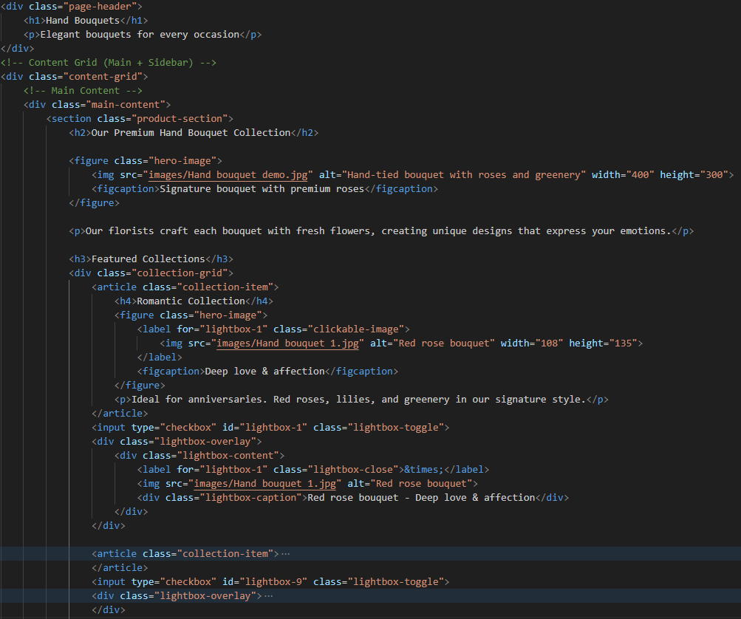

3

2

1

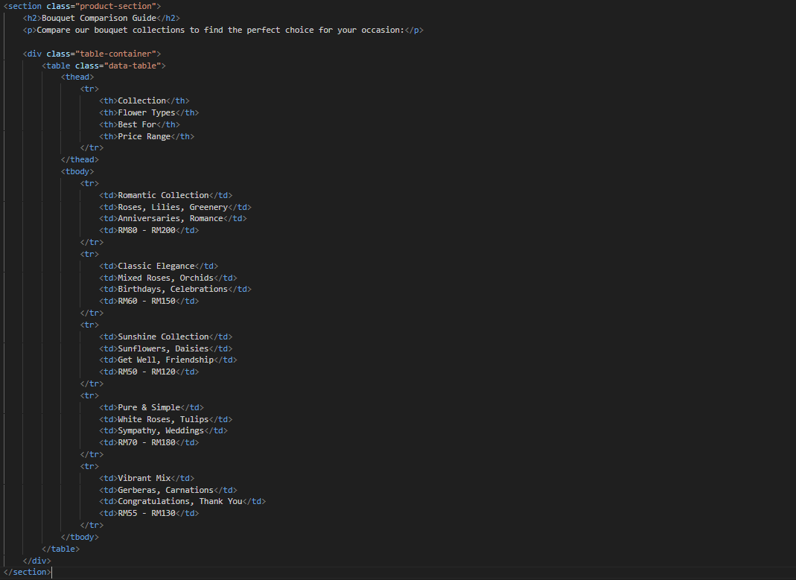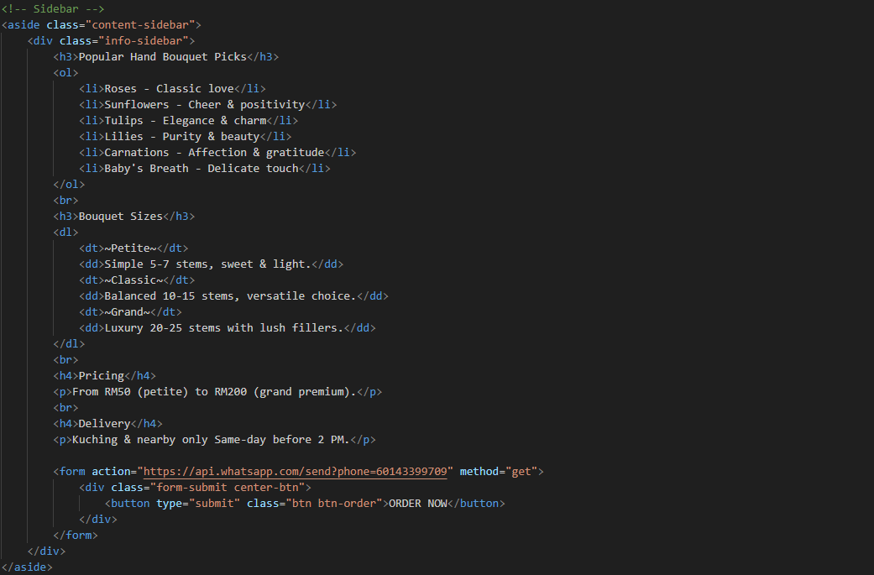

5

4

|  |  |
| --- | --- |
| No. | Description |
| 1 | Product page header   * Includes main heading “Hand Bouquets” (h1) and short description |
| 2 | Product introduction   * Divides layout into main content and sidebar sections (aside). * Main content holds the product section within a div. * Product section includes a subheading, image, and caption (figcaption). * A phrase describes the florist (h2), followed by a short text. |
| 3 | Product collection   * Starts with subheading (h3) and multiple collection articles. * Each article has a heading (h4), figure, and description. * Figure includes clickable image and caption inside a label. * Below each article is a checkbox lightbox toggle. * Lightbox overlay shows close button, large image, and caption. |
| 4 | Product comparison   * Section titled “Bouquet Comparison Guide” (h2) * Paragraph introduces comparison of collections * table lists collections, flower types, occasions, price ranges, with thead and tbody * Five collections included: Romantic, Classic, Sunshine, Pure, Vibrant |
| 5 | Purchase info & contact   * Contains info-sidebar with extra floral details. * Starts with heading “Popular Hand Bouquet Picks” and ordered list (ol). * Next heading “Bouquet Sizes” introduces a description list (dl). * Subheading (h3) “Pricing” followed by short pricing paragraph. * Subheading “Delivery” explains delivery details and cutoff time. * Ends with WhatsApp order form and centred “ORDER NOW” button. |

## Workshop Page

The workshop page is designed to give visitors a clear overview of all available classes. It begins with a header and introductory section, followed by detailed workshop categories presented in interactive cards. Each card features a front with an image and title, and a back with duration, learning outcomes, materials, and price, making it easy for users to understand what each workshop offers.

Additional sections include a learning structure with key outcomes, a comparison table to help choose the right workshop, and a sidebar with fees, inclusions, and requirements. The page also features student testimonials and a registration form, providing both social proof and a straightforward way for users to enroll.

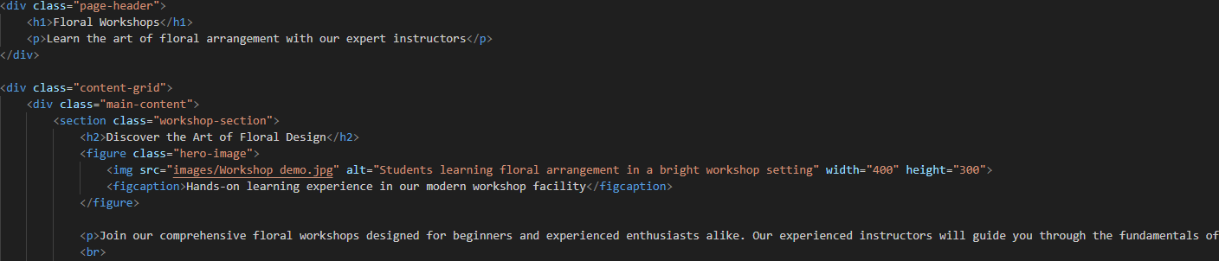

1

2

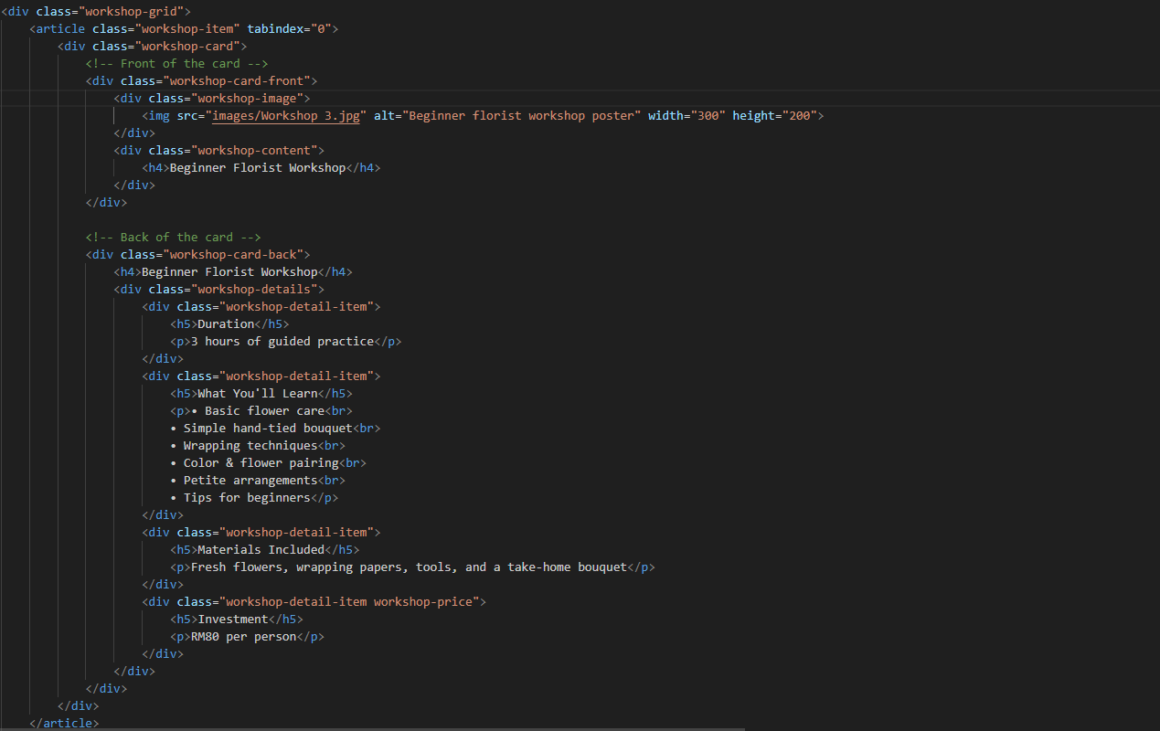

3

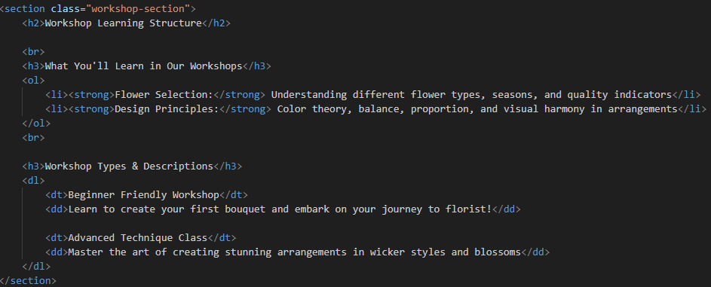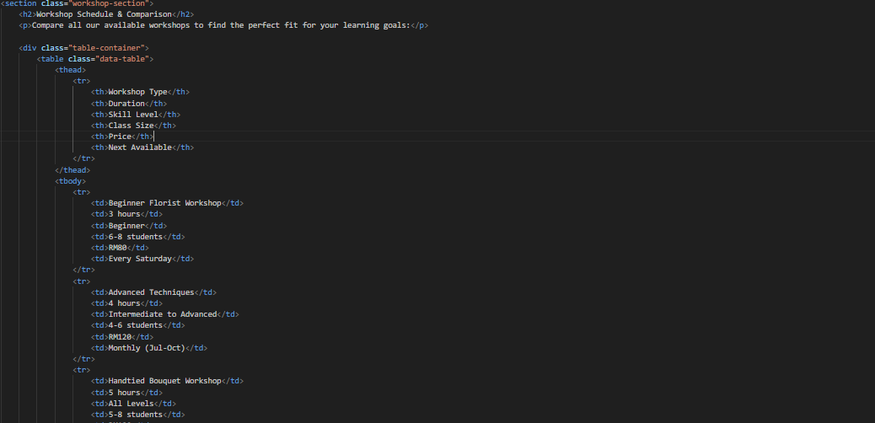

5

4

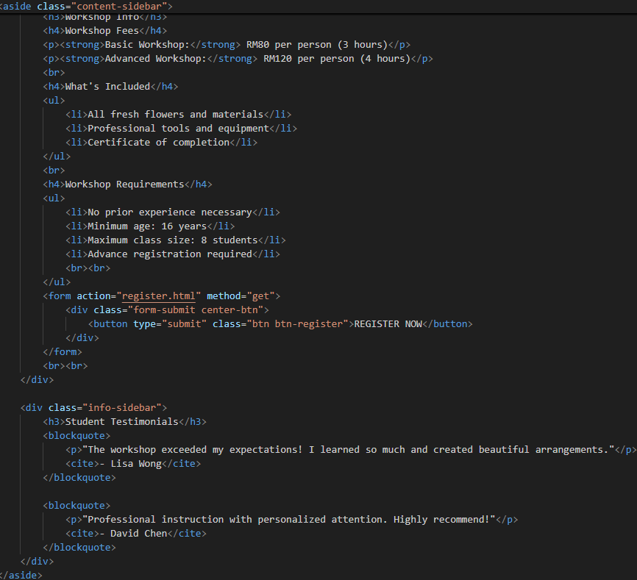

6

7

|  |  |
| --- | --- |
| No. | Description |
| 1 | Workshop page header   * Includes main heading (h1) and short description. * Uses content grid layout for main page area. |
| 2 | Workshop Introduction   * Starts with subheading (h2) introducing the workshop. * Followed by hero image and caption in a figure. * Below is a paragraph describing the workshop overview. |
| 3 | Workshop Categories   * Uses content grid with main area for workshop details. * Begins with subheading (h2), hero image, and short description. * Subheading (h3) introduces workshop categories. * Workshop grid holds multiple workshop items (article). * Each card has front and back sides:   - Front: workshop image (div) and title (h4).  - Back: title (h4), subheadings (h5), and paragraphs detailing duration, outcomes, materials, and price. |
| 4 | Workshop Learning Structure Section   * Begins with subheading (h2) for learning structure. * “Learning Outcomes” (h3) introduces an ordered list (ol) of topics. * “Workshop Types” (h3) introduces a description list (dl) with terms (dt) and descriptions (dd). |
| 5 | Workshop schedules and comparisons   * Section heading introduces workshop schedule and comparison (h2). * Short paragraph explains purpose of comparing workshops. * table shows workshop types with key details. * Columns include type, duration, skill level, class size. * Additional columns list price and next available session. |
| 6 | Workshop fees, inclusions and requirements   * In aside, begins with heading (h3) “Workshop Info.” * Contains subheadings (h4) for Fees, Inclusions, and Requirements. * Fees are written in paragraphs (p) with bold labels. * Inclusions are listed in an unordered list (ul). * Requirements are also listed in another unordered list (ul). * Ends with a registration form (form) containing a submit button inside a styled div. |
| 7 | Workshop students’ testimonials   * Begins with heading (h3) “Student Testimonials.” * Each testimonial is enclosed in a blockquote, containing: A paragraph (p) with student feedback. A citation (cite) with the student’s name. |

## Promotion Page

The promotion page provides an engaging overview of the florist’s latest deals and seasonal offerings. It begins with a clear header featuring the main heading and a short descriptive paragraph to draw attention. The main content highlights limited-time offers through a visually organized grid of promotional cards, each displaying an image, title, caption, discount, details, and a link to the florist’s Instagram page. This layout ensures customers can quickly scan and explore current promotions with ease.

A dedicated Promotion Calendar section allows users to plan ahead by presenting a year-round schedule in a structured table. Each month lists the promotion name, discount, applicable products, and special benefits, making it simple to identify deals that suit their needs. Additional information covers redemption methods, terms, and conditions, along with a convenient WhatsApp contact button for inquiries. Customer testimonials further enhance trust, showcasing favourites and encouraging engagement with the brand’s offerings.

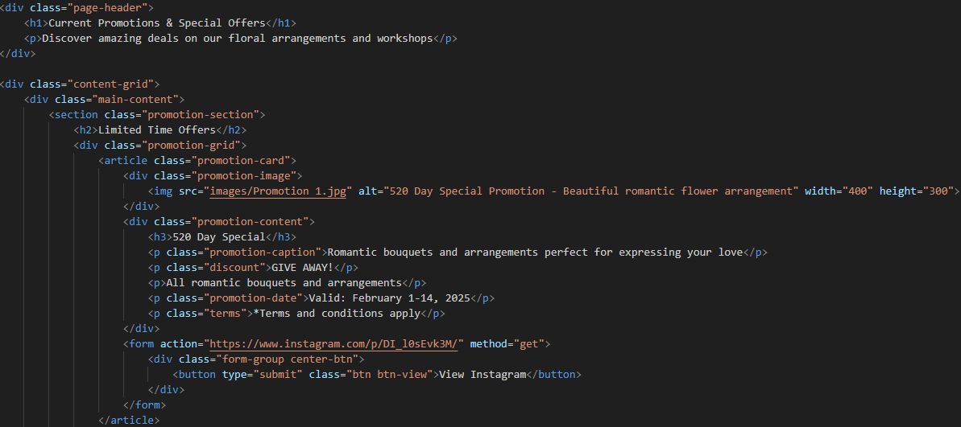

2

1

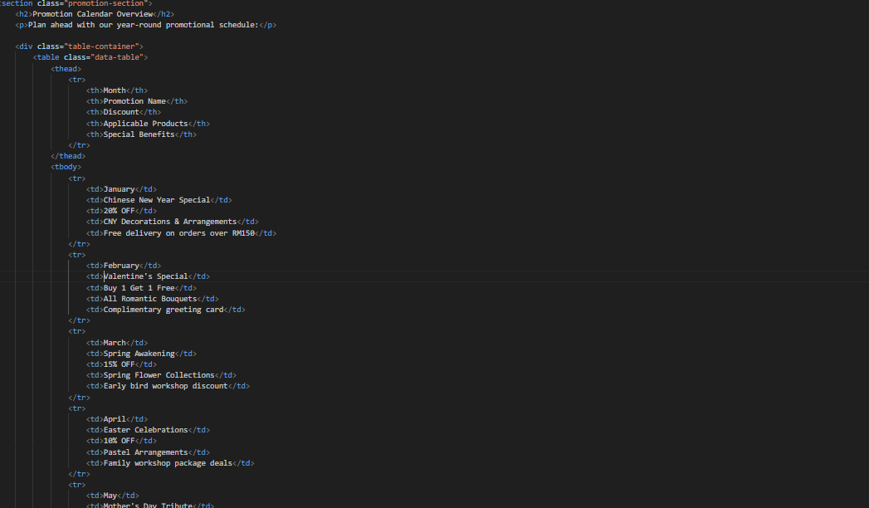

3

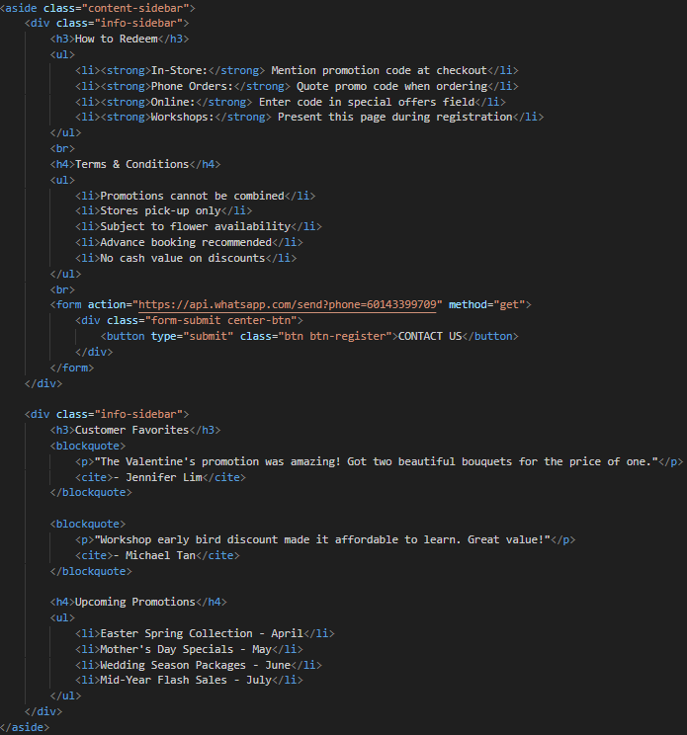

4

5

|  |  |
| --- | --- |
| No. | Description |
| 1 | Promotion page header   * Wrapped in a div with class page-header. * Contains the main heading displayed using an h1 tag. * A short descriptive paragraph is placed directly below the heading. |
| 2 | Promotions content   * Uses content grid wrapper for layout organization. * Main content includes section titled “Limited Offers.” (h2) * Section contains grid of promotional article cards. * Each card has image and content containers. * Includes title, caption, discount, details, and terms. * Button links to florist’s Instagram page. |
| 3 | Promotion calendar section   * Uses table. * Starts with heading (h2) “Promotion Calendar Overview.” * Short paragraph explains the year-round schedule. * table shows month, promotion name, discount, applicable products, special benefits. * Helps users plan purchases and take advantage of deals. |
| 4 | Promotion redemption info   * Contains two info blocks. * Subheading (h3) “Savings Methods” followed by ordered list (ol). * List covers bulk orders, loyalty points, birthday discounts. * Followed by terms and conditions in definition list (dt). * WhatsApp contact button placed below the lists. |
| 5 | Customers’ testimonials   * Highlights customer favourites through testimonial blockquotes. * Upcoming promotions are listed with month-based items listed below. |

## Workshop Registration Page

The workshop registration page provides a structured form for participants to sign up for floral workshops. It begins with a form header introducing the purpose and guiding users with a short description. The form is organized into clear sections for personal details, address, contact, and scheduling, ensuring accurate participant information is collected.

Users can specify their preferred workshop date, number of participants, type of workshop, and experience level, helping the florist tailor the sessions. Additional space is provided for comments or special requests. Options to subscribe to newsletters and agree to terms and conditions are included for clarity and consent. Finally, the page offers clear submission and reset buttons, making the process straightforward and user-friendly.

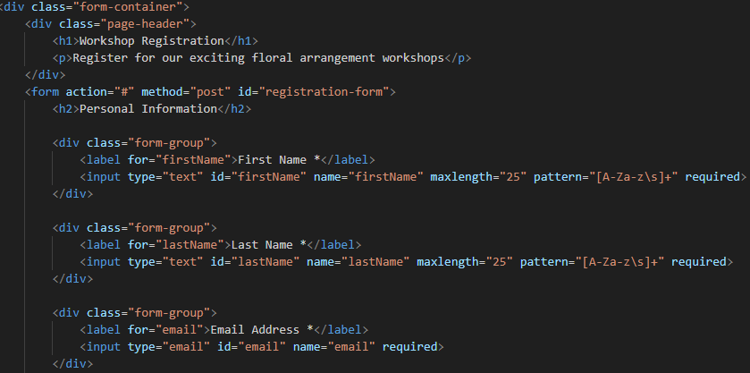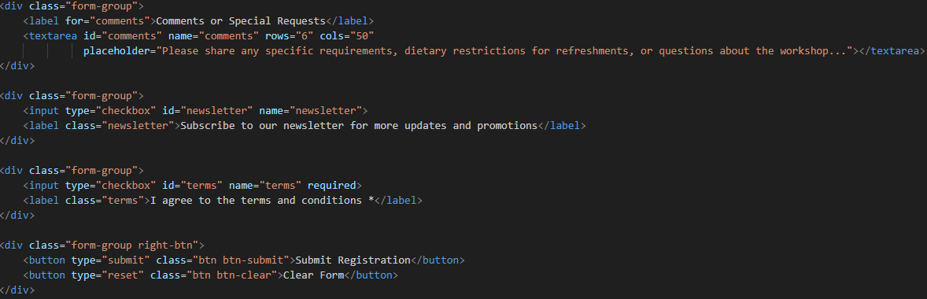

9

10

8

2

1



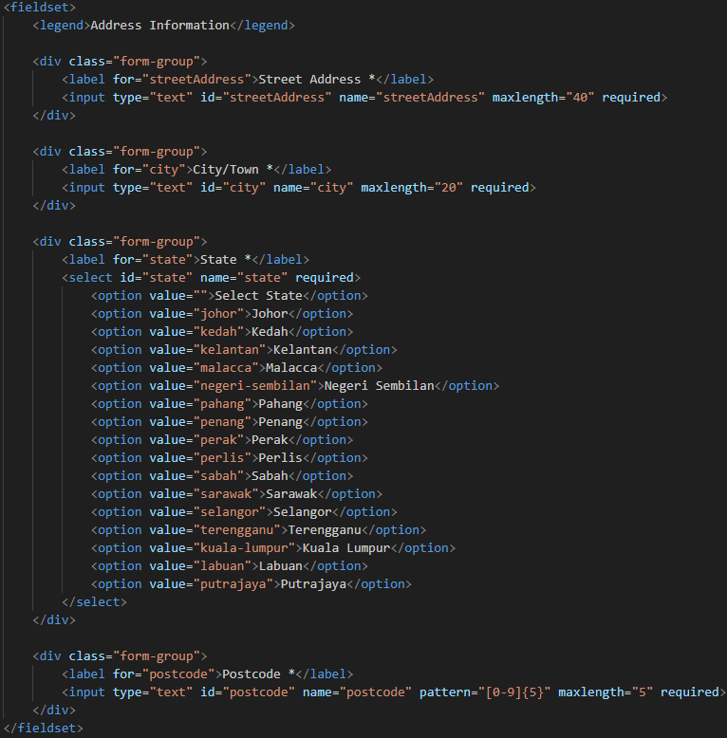

3

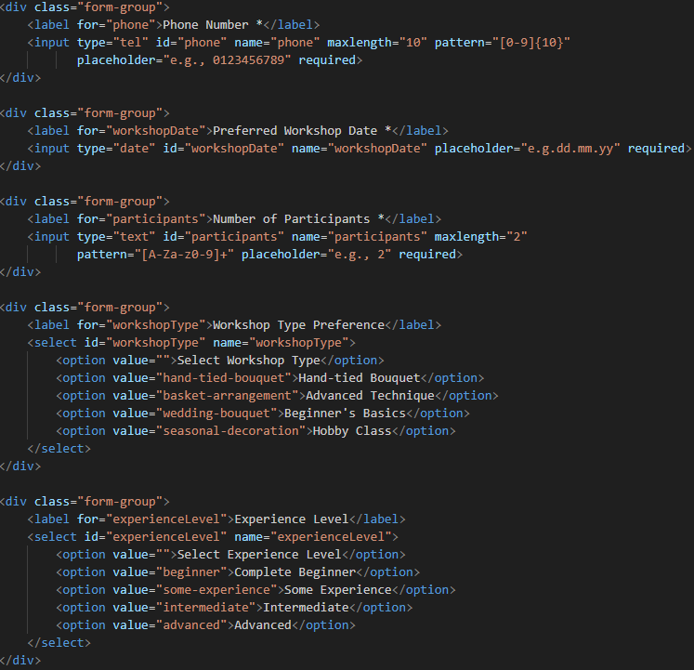

7

6

4

5

|  |  |
| --- | --- |
| No. | Description |
| 1 | Workshop Registration Form Container   * Wrapped in a div with class form-container. * Header includes form title (h1) and short description. * Main form uses method="post" and id="registration-form". * “Personal Information” section groups labelled input fields with validation. |
| 2 | Personal Information Fields   * • First and last name use text inputs with limits. * • Both name fields require only alphabetical input (pattern="[A-Za-z\s]+"). * • Email field uses type="email" for format validation. * • All fields are required for form submission. |
| 3 | Address Information Fieldset   * Wrapped inside a fieldset with legend “Address Information.” * Contains street address and city fields (input type="text") with maximum limits of 40 and 20 characters, both required. * State field uses dropdown of Malaysia states. * Postcode field requires 5-digit input (maxlength="5") with pattern="[0-9]{5}". |
| 4 | Contact and Scheduling Fields   * Phone number uses input type="tel" limited to 10 digits with pattern and placeholder for format clarity. |
| 5 | Scheduling   * Preferred workshop date uses input type="date" to ensure valid date selection. |
| 6 | Number of participants   * Short text input of two characters, with alphanumeric input (pattern="[a-zA-Z0-9]+"). |
| 7 | Workshop and Experience Selection   * Two dropdowns (select) provided: - Type: Hand-tied Bouquets, Advanced Techniques, Beginner’s Basics, Hobby Classes. - Experience level: Complete Beginner to Advanced. |
| 8 | Additional Comments Section   * textarea with six rows and fifty columns for comments or special requests. * Includes a placeholder prompting users to share requirements or questions. |
| 9 | Subscription and Agreement Options   * Two checkboxes: newsletter subscription (optional), terms and conditions agreement (required). |
| 10 | Form Buttons   * Enclosed in a div with class right-btn. * Contains a “Submit Registration” button and a “Clear Form” button. * Ensures users can easily submit or restart the form process. |

## Enquiry Page

The enquiry page is designed to let customers easily reach out with questions, feedback, or requests. It starts with a clear header introducing the form’s purpose. The form itself is divided into structured sections, beginning with contact details such as name and email, ensuring users provide valid and complete information.

An address section follows, collecting location and phone number for better communication. Users can then specify the type of enquiry from a dropdown, covering products, membership, or workshops, which helps direct their request to the right area. A comments box is included to allow detailed input. At the end, simple submit and reset buttons give users control to send their enquiry or clear the form for corrections.

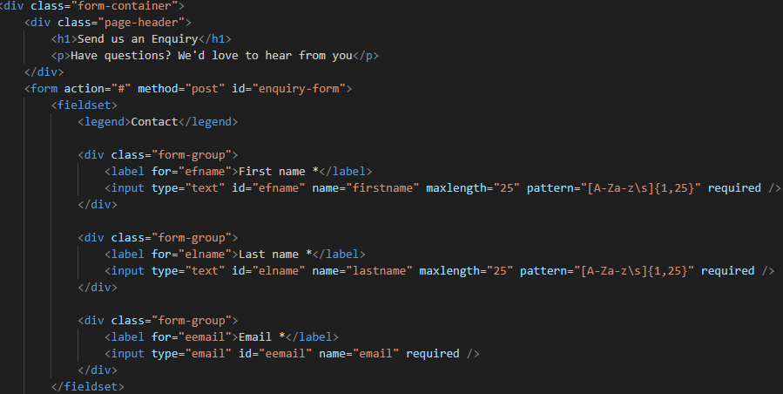

2

1

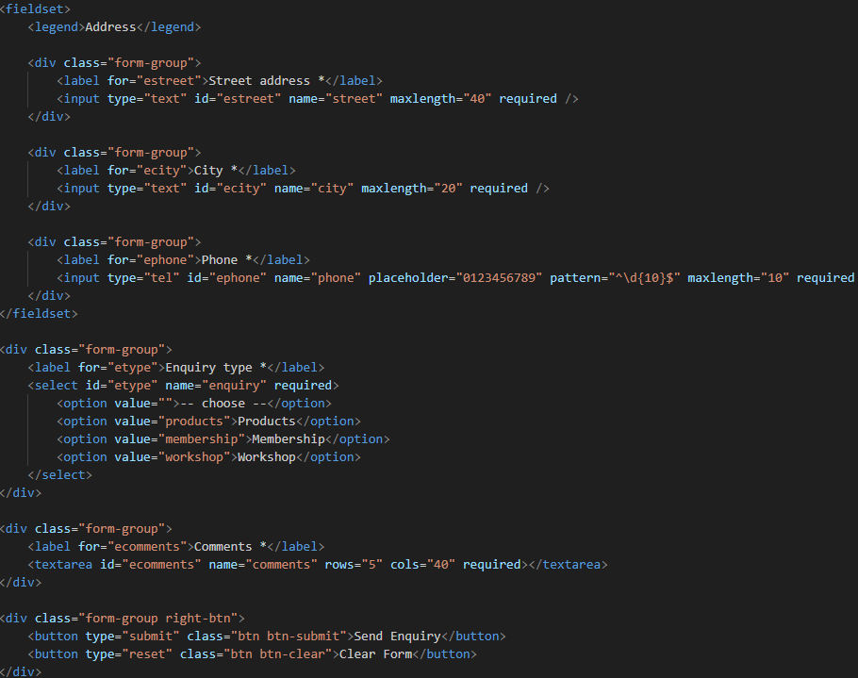

6

5

4

3

|  |  |
| --- | --- |
| No. | Description |
| 1 | Enquiry Form Container   * Enclosed in a div with class form-container. * Page header includes heading (h1) and short description (p). |
| 2 | Form Setup and Contact Fields   * Form uses method="post", and id="enquiry-form". * Fieldset groups inputs under legend “Contact.” * Three form-group divs for name and email fields. * First and last name use text inputs with validation. * Email field ensures proper address format. * Layout ensures clear and validated contact input. |
| 3 | Address Fieldset   * Wrapped in a fieldset with legend “Address.” * Includes three form-group divs for address details. * Street address uses text input, maxlength 40, required. * City uses text input, maxlength 20, required. * Phone uses tel input, pattern “[0-9]{10}”, required, with placeholder=”012345678”. * Ensures complete and correctly formatted contact details. |
| 4 | Enquiry Type Selection   * form-group with label and select dropdown titled “Enquiry Type *”. * Required selection with placeholder option “-- choose --”. * Includes three predefined options: Products, Membership, Workshop. |
| 5 | Comments Section   * form-group with label and textarea titled “Comments *”. * Required field with rows="5" and cols="40" for user input. * Allows users to provide detailed feedback or questions. |
| 6 | Form Buttons   * Buttons enclosed in a div with class right-btn. * Submit button labelled “Send Enquiry” to submit form. * Reset button labelled “Clear Form” to erase all entries. * Provides user-friendly control for submission or correction. |

## Profile Page

The profile page presents personal and academic information in a structured way. It begins with a profile wrapper that displays the student’s photo, name, ID, and course details for quick identification. A dedicated details section follows, using a centred table to neatly organize information such as demographics, hometown, achievements, and personal favourites, making it easy for readers to learn more about the individual. Finally, a simple contact form with a mailto link allows visitors to reach out directly via email, ensuring both personal introduction and accessibility are combined on one page.

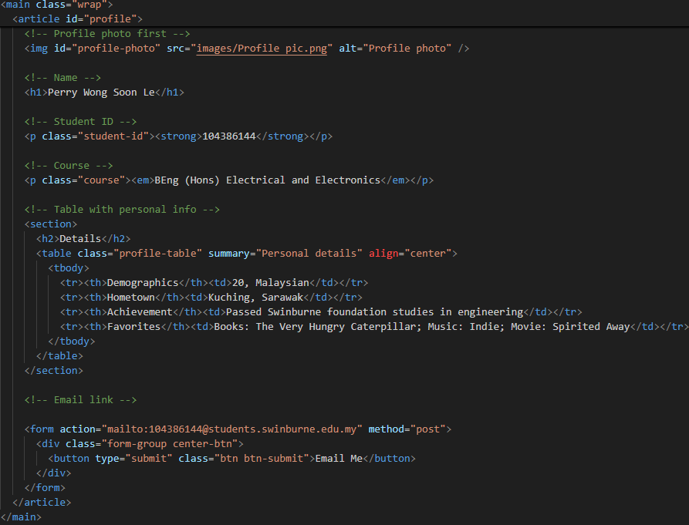

4

3

2

1

|  |  |
| --- | --- |
| No. | Description |
| 1 | Profile page wrapper   * Enclosed within a main container with class wrap. * Main content structured inside an article with the ID profile. * ID profile-photo displays the profile picture (img). * Name shown in heading (h1). |
| 2 | Basic Information   * Student ID (p) with class student-id and styled in bold. * Course name (p) with class course, shown in italic text. |
| 3 | Details Section   * A section introduces the “Details” subsection (h2). * A table is used to present key information, aligned at the centre. * Table headers (th) include categories like demographics, hometown, achievement, and favourites, with corresponding (td) data values. |
| 4 | Contact Form   * A form element with mailto: action for direct email contact. * Inside a styled form-group, a button labelled “Email Me” enables users to send an email upon clicking. |

## Enhancement Page

The CSS Enhancements page showcases five key interactive techniques implemented across the Root Flower website. Each section includes a live demo and detailed technical explanation, covering dropdown menus, 3D flip cards, a CSS-only image lightbox, advanced hover effects, and a responsive hamburger menu. These enhancements improve usability, accessibility, and visual appeal while maintaining a lightweight, JavaScript-free approach.

Together, these features provide both aesthetic and functional improvements. Dropdown menus and flip cards enhance content presentation, the lightbox allows elegant image viewing, hover effects engage users with subtle animations, and the responsive hamburger menu ensures smooth navigation on mobile devices. This page effectively documents the creative CSS strategies that elevate the website’s user experience.

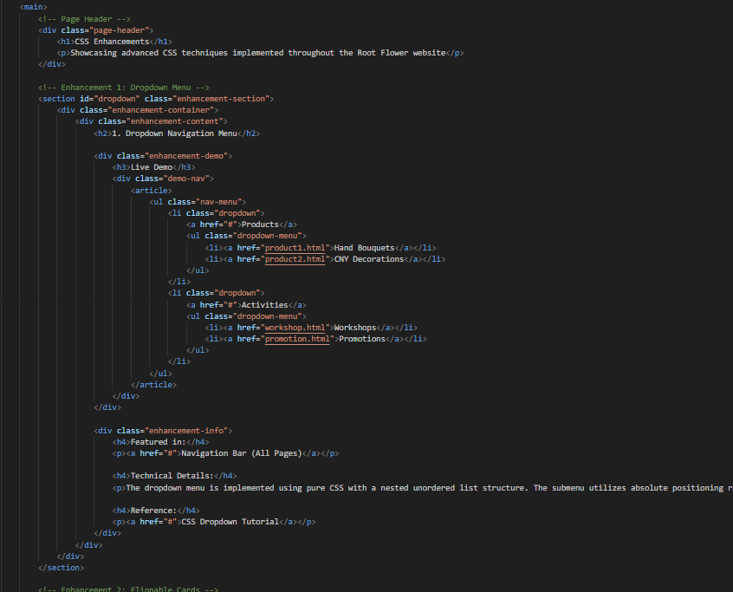

1

2

|  |  |
| --- | --- |
| No. | Description |
| 1. | Enhancement demonstration section   * Each is one enhancement-section with container and content * Shows live demo of the CSS enhancement. * Users can interact and observe effect. |
| 2. | Enhancement details   * Enclosed in enhancement-info * Explains technical implementation of enhancement. * Includes featured page reference and notes. |

## Acknowledgement Page

The Acknowledgement page provides a clear record of sources and references used throughout the website. It includes two main sections: Info and Image References, which lists social media sources like Instagram and Facebook in a simple table format, and Technical References, which documents the origin of various coding features, linking each to its respective online source for verification. This page ensures proper credit is given and allows visitors to explore the original materials and tutorials.

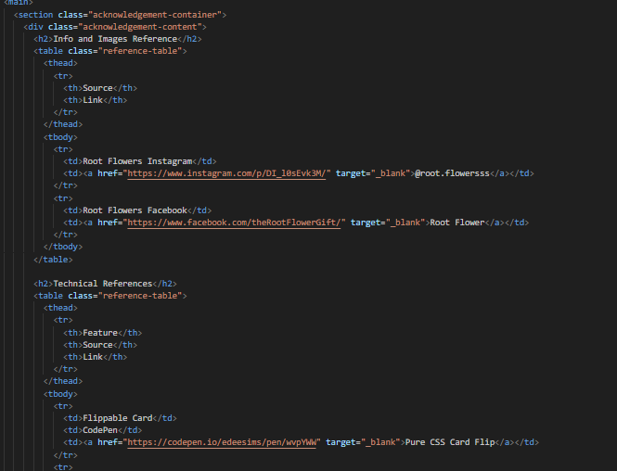

1

2

|  |  |
| --- | --- |
| No. | Description |
| 1. | Info and image references   * Listed with table with source and link column. * Includes Instagram and Facebook sources. |
| 2. | Technical references   * Listed with table with feature, source and link column. * Each source links to website for verification. |

## Site Map

The site map shows the HTML files structure of the website.

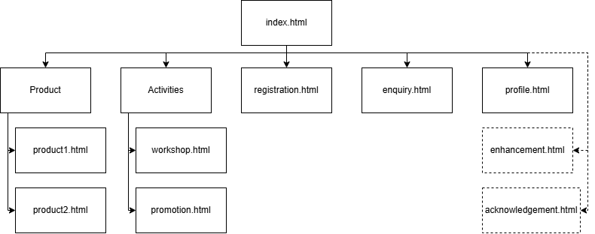

# Website Style

This section outlines the CSS styles used in the website, with no JavaScript. Some of the stylings are used repeatedly throughout the website or among a few pages to ensure consistent outlook.

## General Style

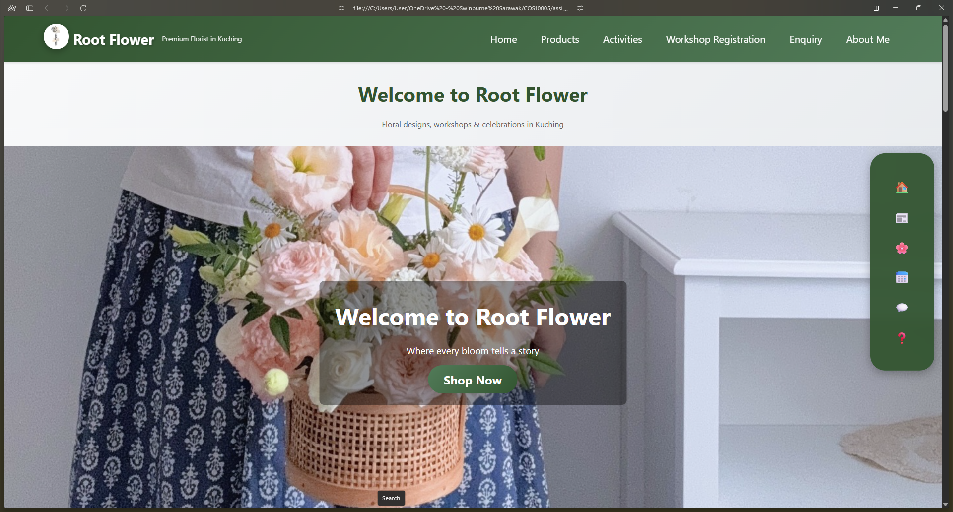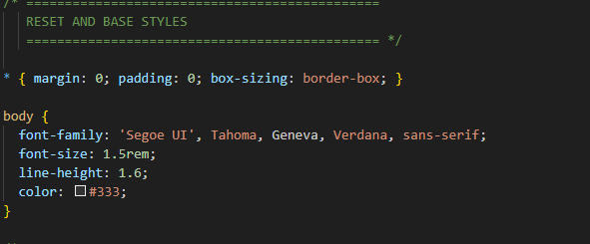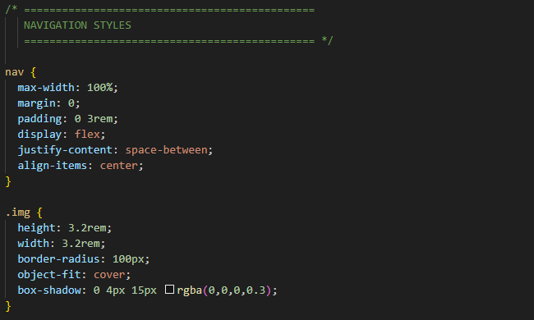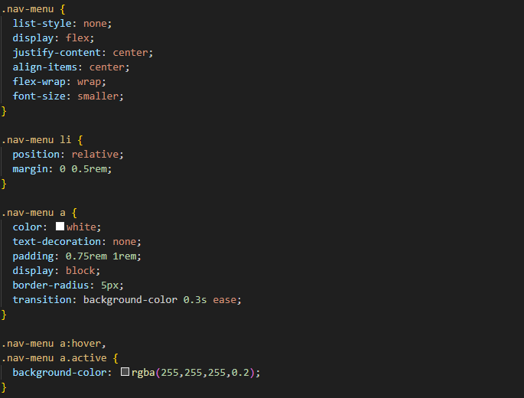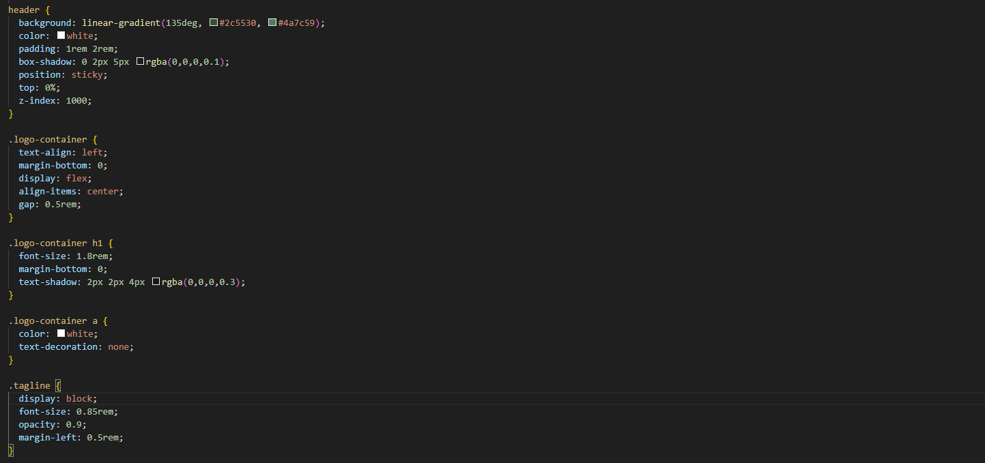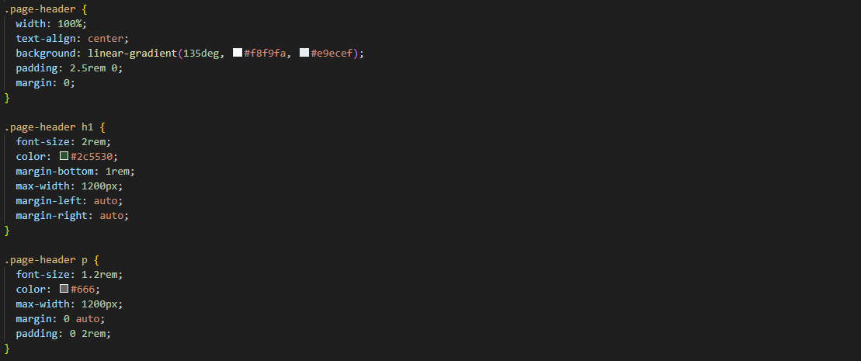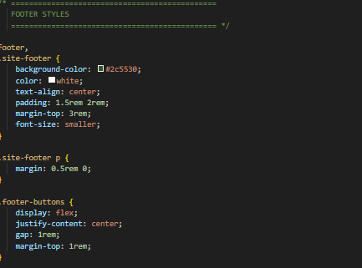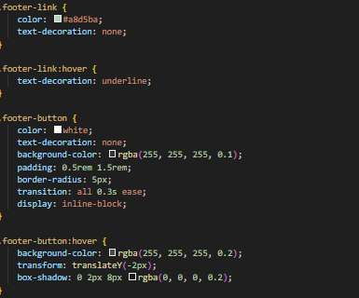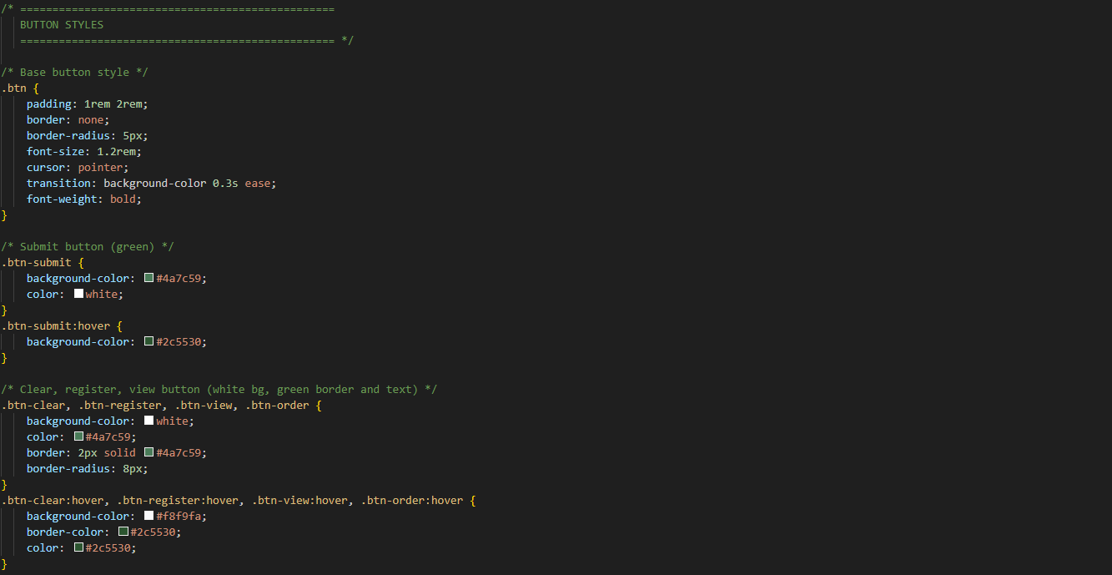

1

2

2

5

2

4

3

3

5

4

6

5

|  |  |
| --- | --- |
| No. | Description |
| 1 | Body style   * Removes default margin and padding from all elements. Applies box-sizing: border-box, so width/height include padding and border. * Sets a clean, sans-serif font stack for the entire page. * Increases the base font size (1.5 times the root element size). * Improves readability by giving space between lines of text. * Text colour to a dark grey for better contrast than pure black. |
| 2 | Navigation panel   * Full-width nav with horizontal padding. * Uses flexbox: logo left, menu right. * Logo image 3.2rem × 3.2rem, rounded. * Menu list removes bullets, flex row. * Menu links white, padded, smooth hover. * Hover/active: semi-transparent white background. |
| 3. | Logo and Header   * Logo container uses flex, gap 0.5rem. * Logo text size 1.8rem with shadow. * Clickable logo text/image. * Tagline on new line, smaller, slightly transparent. |
| 4 | Page header   * Full-width, centered text, gradient background. * Vertical padding 2.5rem, no margin. * Heading 2rem, dark green, centered. * Paragraph 1.2rem, grey, centered with padding. |
| 5 | Footer   * Dark green background, white text, centred. * Padding 1.5rem × 2rem, margin-top 3rem. * Paragraph spacing 0.5rem. * Links light green, no underline. * Hover: underline added. * Buttons semi-transparent, rounded, hover effects. |
| 6 | Buttons   * Base buttons padded, rounded, bold text. * Pointer cursor, smooth colour transition. * Submit button green with hover darker. * Other buttons white with green border, hover lighten. |

## Home Page

The homepage uses distinct yet homogenous styling for each section to create visual hierarchy and guide the user’s attention. The hero section features a full-width background with overlayed text, emphasizing the brand and key message immediately upon entering the site. Its large headings, semi-transparent dark overlay, and smooth text positioning make it visually striking while maintaining readability.

In contrast, the call-to-action and sidebar navigation employ vibrant gradients, shadows, and hover effects to encourage interaction. Slides and images use object-fit and fixed sizing to ensure consistency and visual balance. Each section’s unique style—from immersive hero visuals to interactive navigation—helps differentiate content types, improves usability, and keeps the user engaged as they scroll through the page.

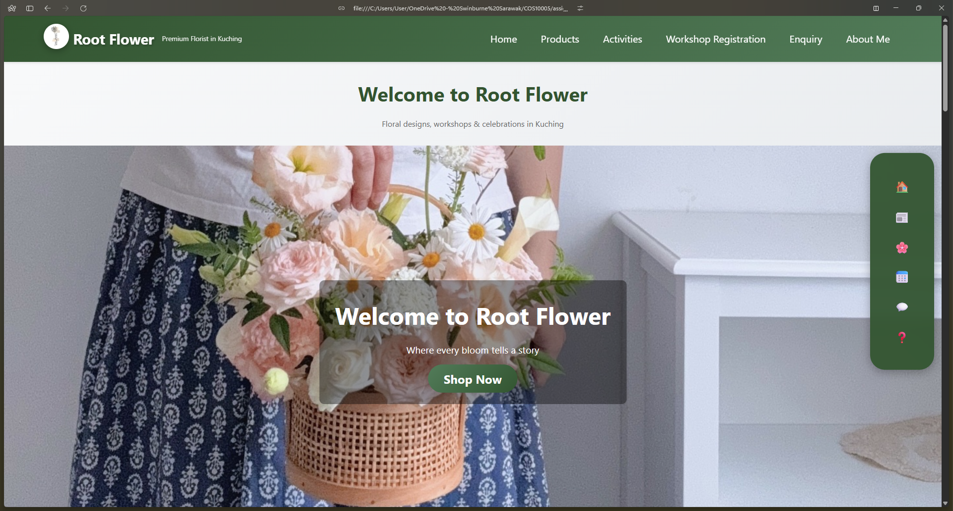

4

3

2

1

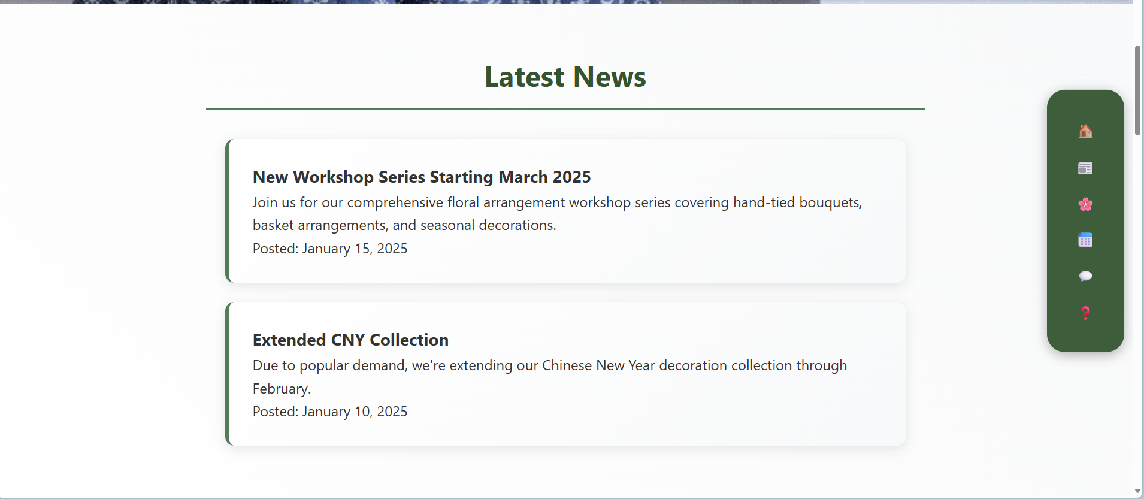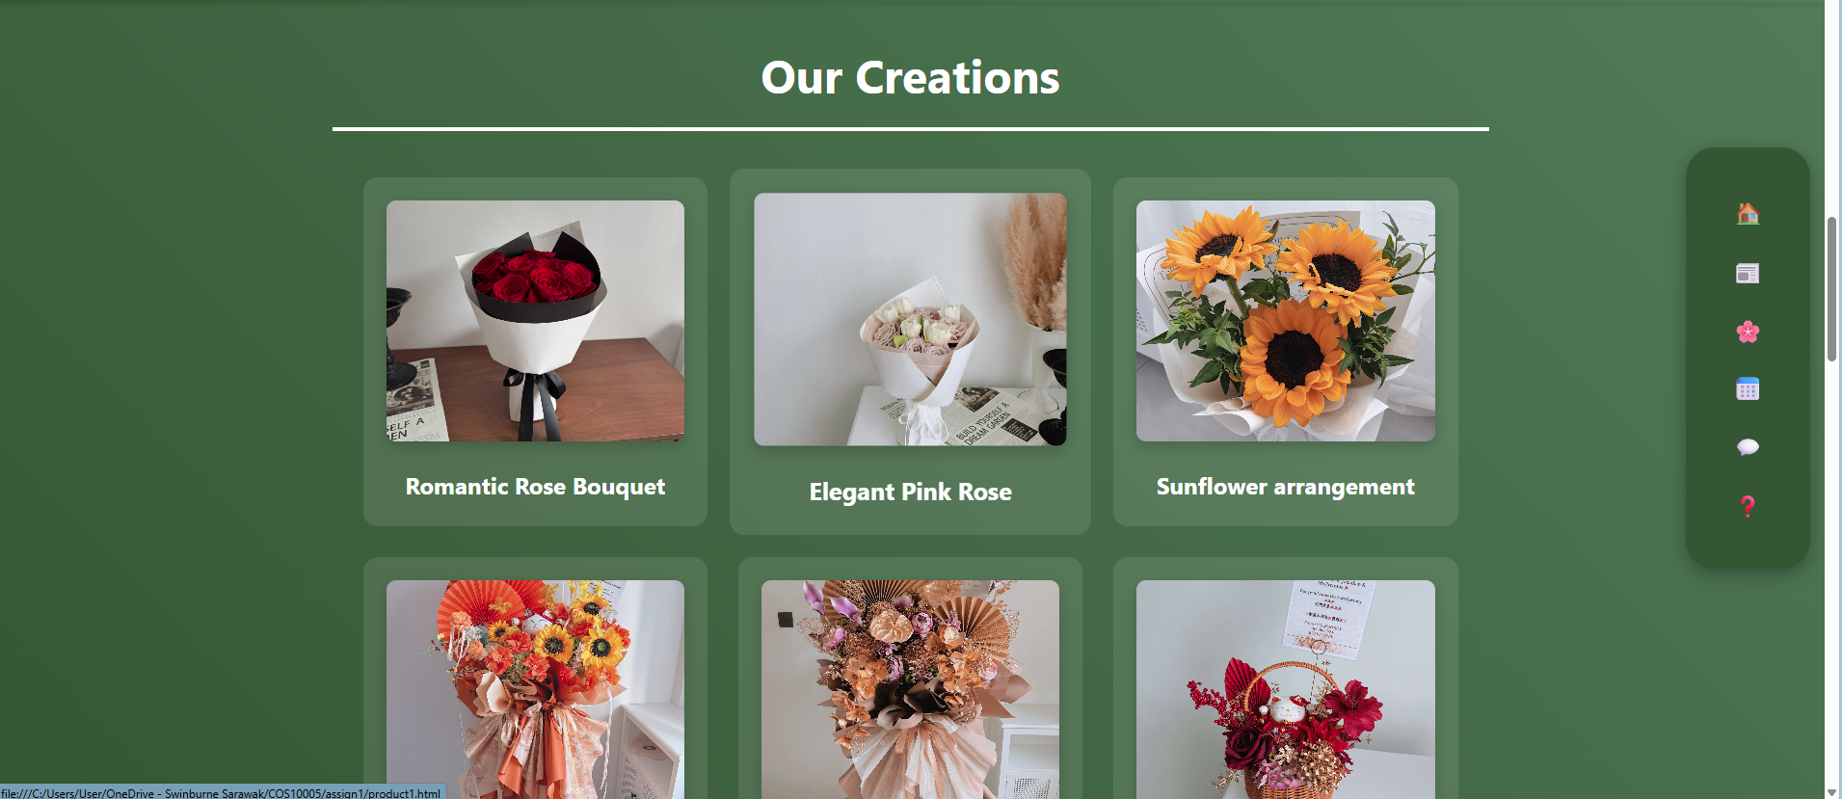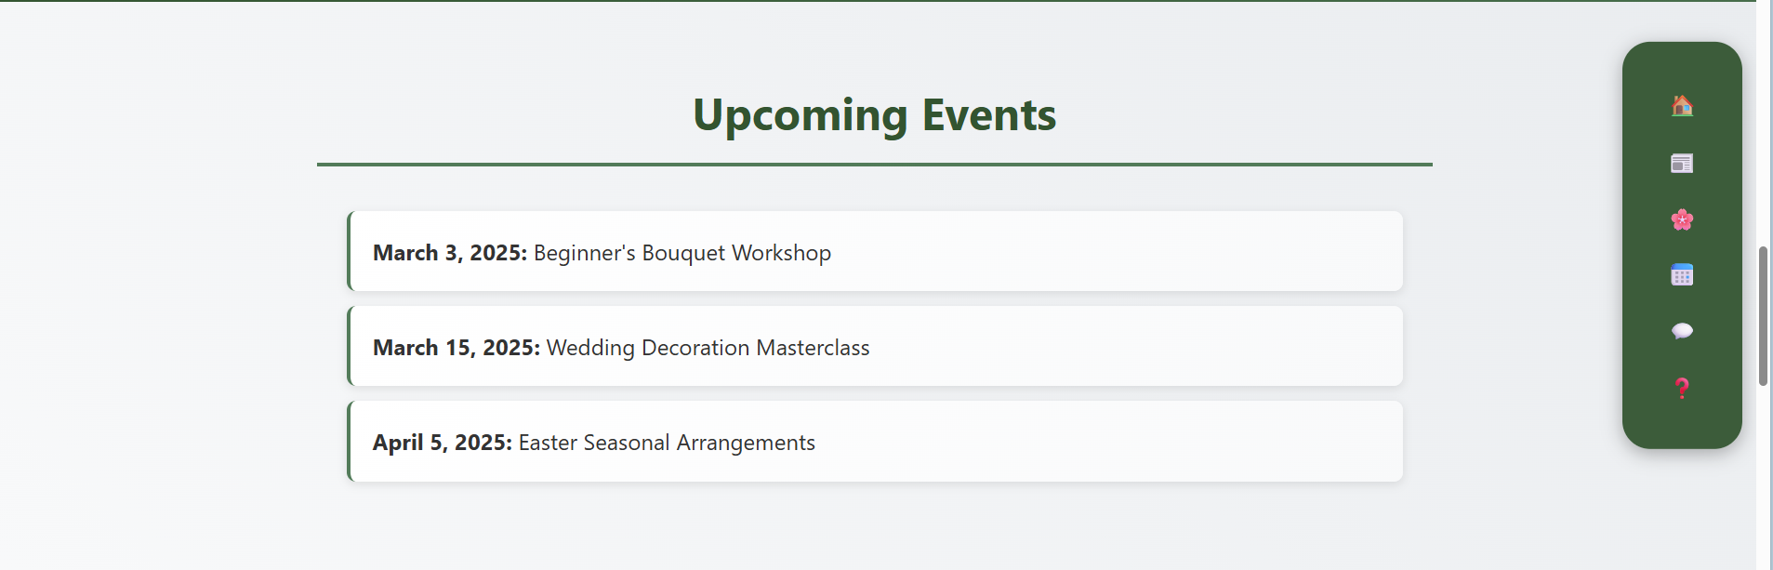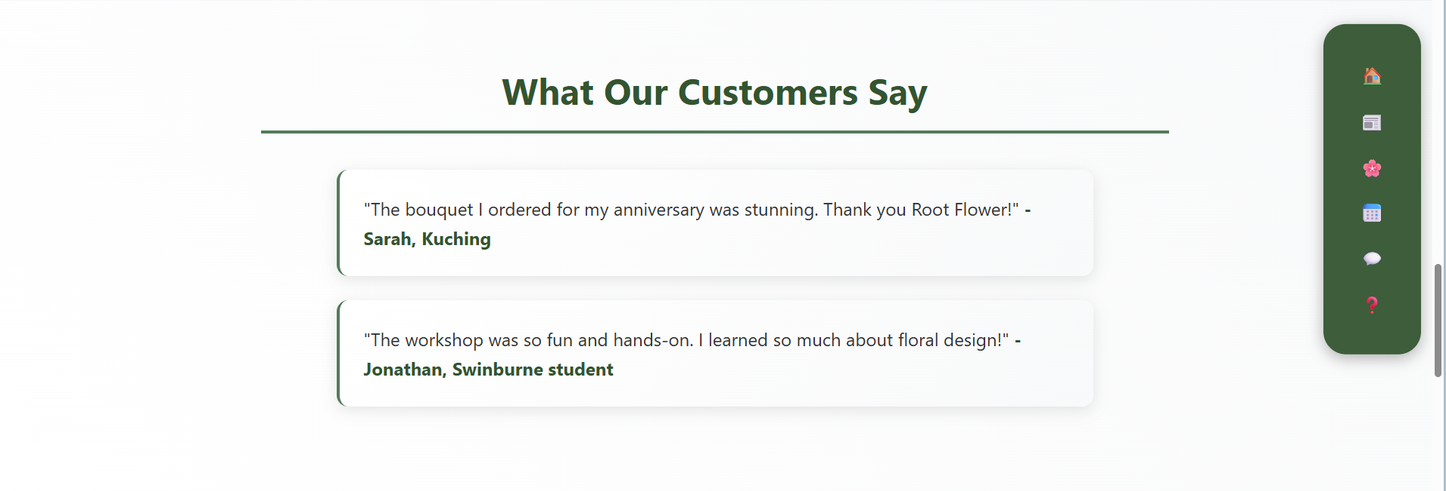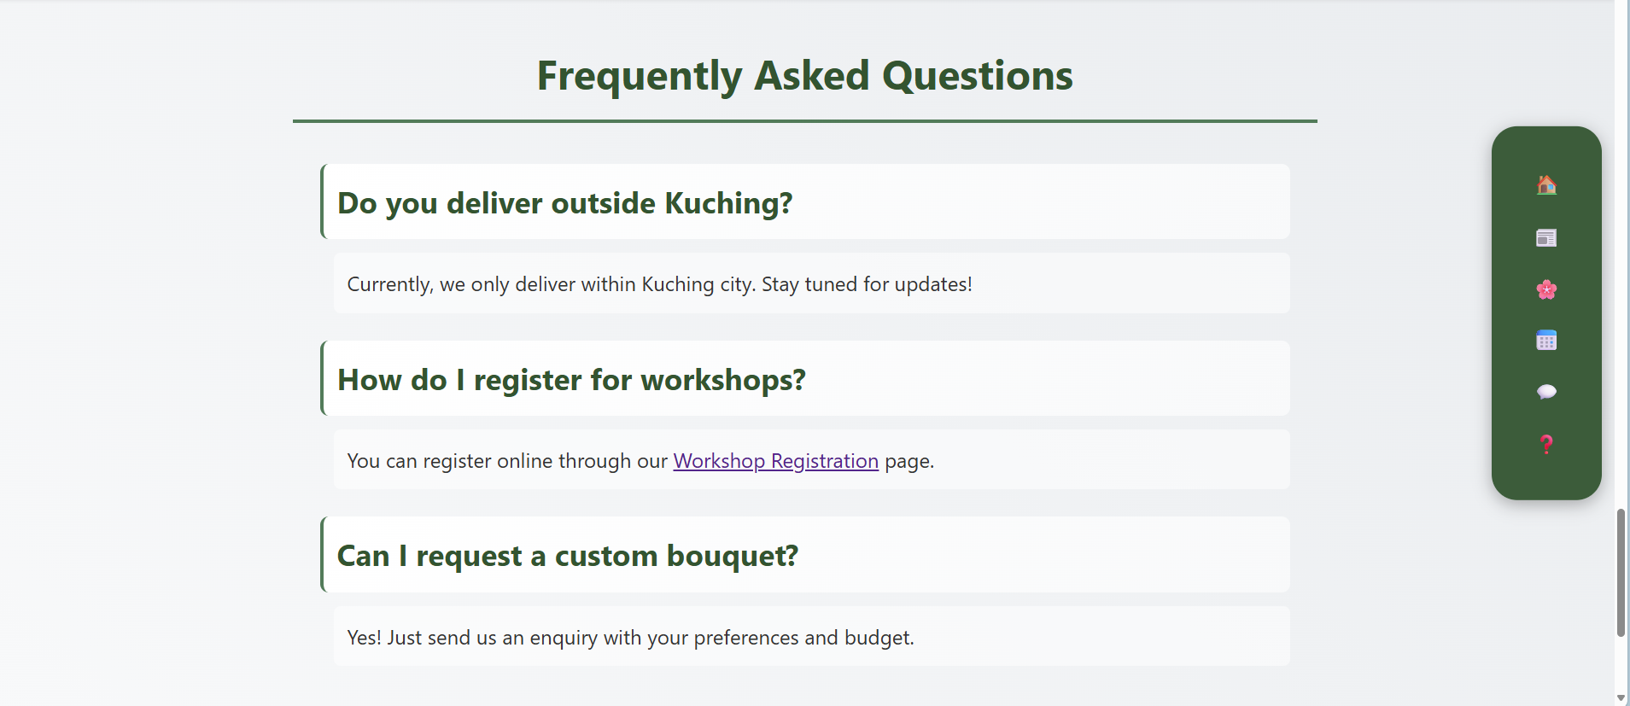

5

8

7

6

9

10

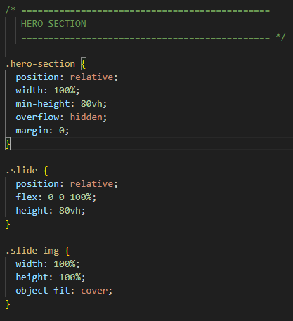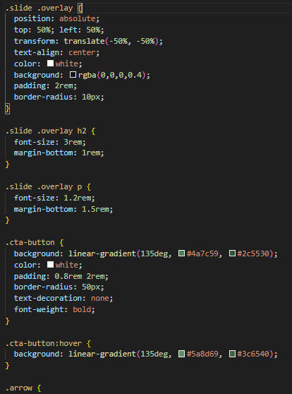

3

2

2

1

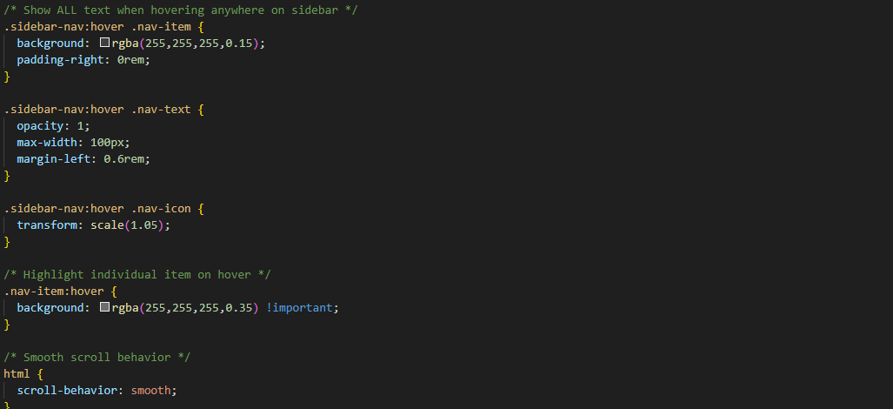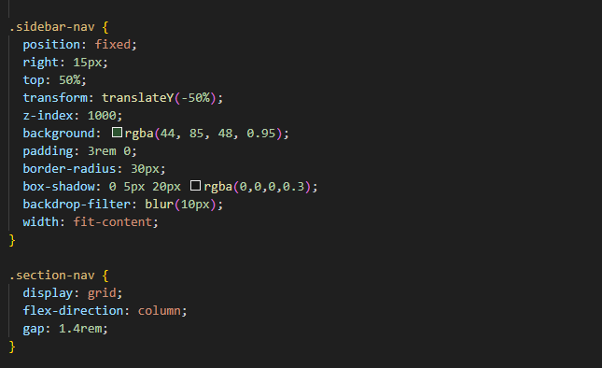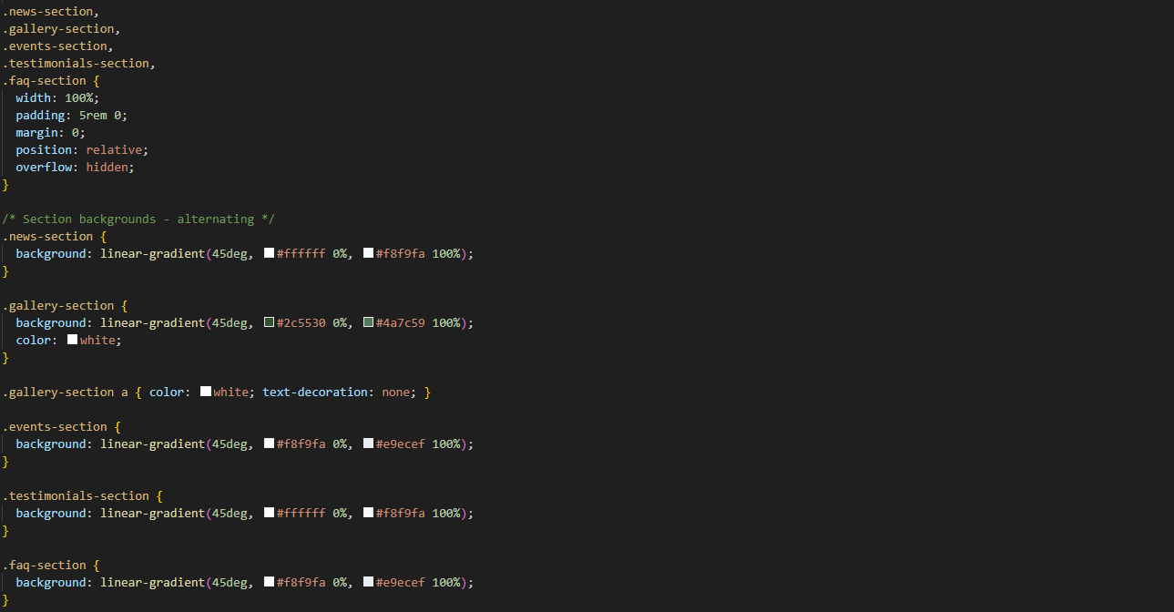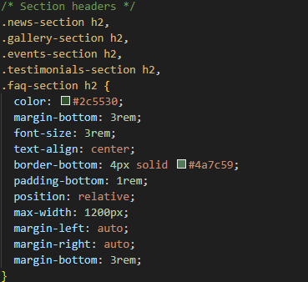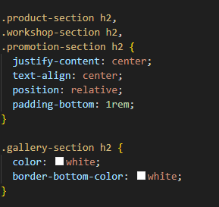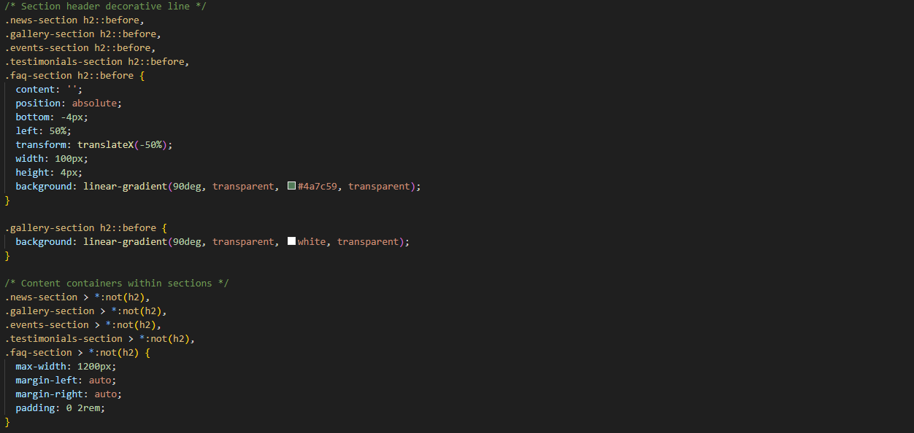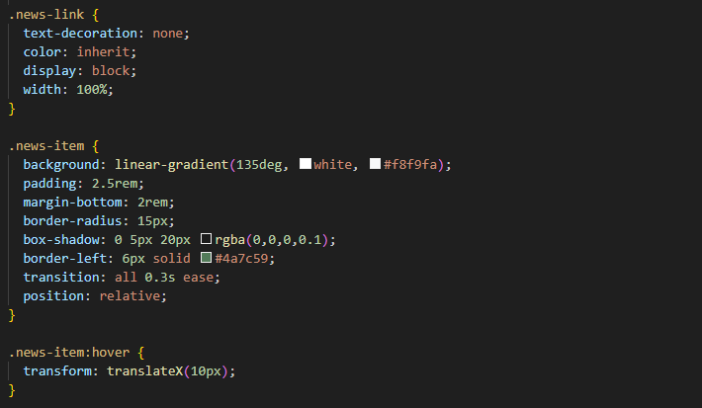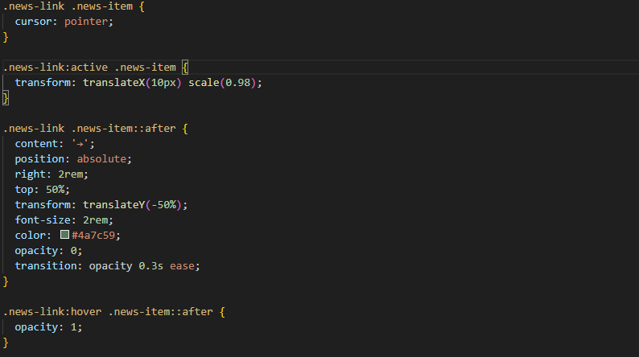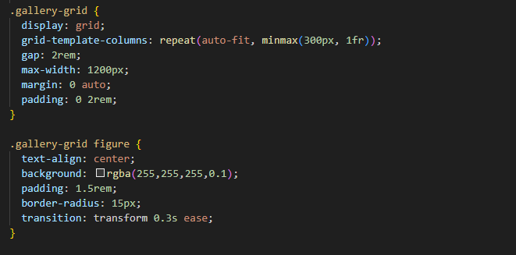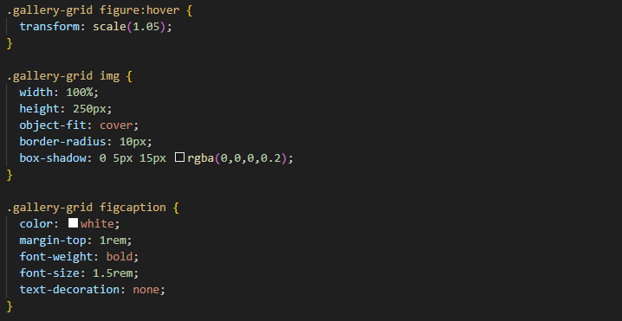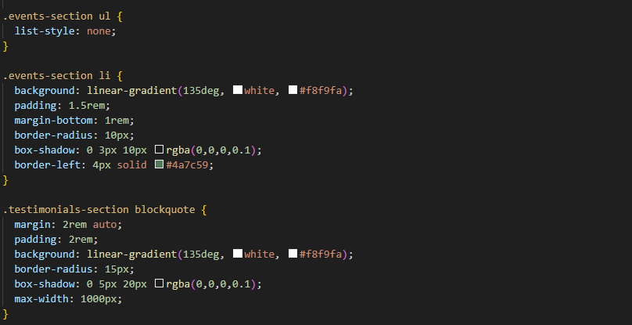

5

5

5

4

5

6

6

7

9

8

7

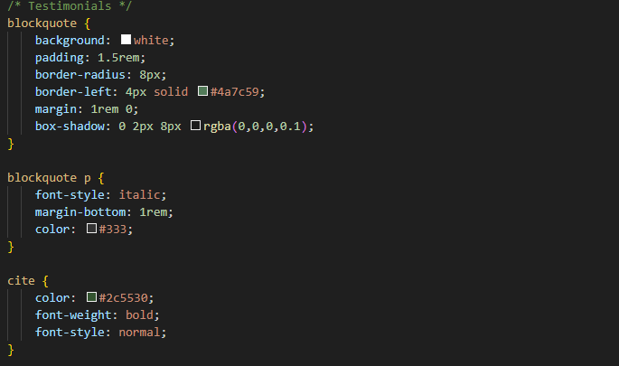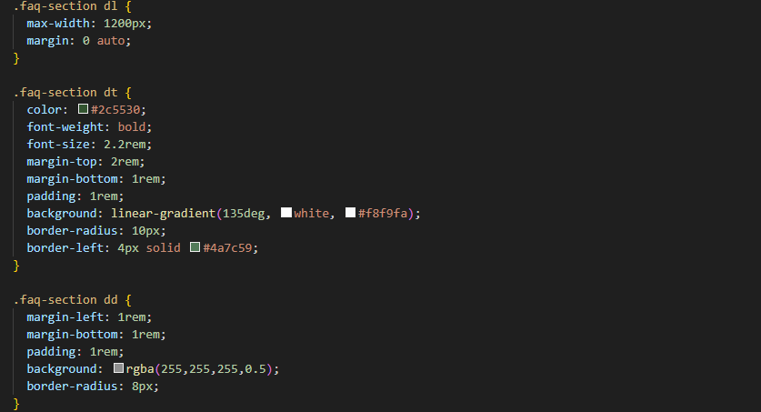

10

9

|  |  |
| --- | --- |
| No. | Description |
| 1 | Hero Section   * hero-section positioned relative, width 100%, min-height 80vh. * overflow: hidden keeps all elements contained. * No margins for full-width, seamless layout. |
| 2 | Slide and Overlay   * slide width 100%, height 80vh, matches hero section. * Images use object-fit: cover for full, undistorted fit. * overlay centred with absolute positioning and transform. * Semi-transparent dark background with white, centred text. * h2 large (3rem) with spacing; p uses 1.2rem font size. |
| 3 | Call-to-Action Button   * cta-button uses green gradient, white text, rounded corners. * Padding shapes button; no text decoration for clarity. * Hover lightens gradient for smooth interactive effect. |
| 4 | Sidebar Navigation   * sidebar-nav fixed right, vertically centred, high z-index. * Semi-transparent dark green background, rounded corners, shadowed padding. * section-nav uses vertical grid layout with even spacing. * Hover effects: background highlight, text fade-in, icon enlarges. * Items brighten slightly on hover for visual feedback. * html uses smooth scrolling for seamless sidebar navigation. |
| 5. | Sections settings   * Full-width sections with 5rem vertical padding. * news, gallery, events, testimonials, faq sections styled separately. * Alternating backgrounds using light and dark linear gradients. * gallery-section uses white text and links for contrast. * Section headers centred with decorative bottom line. * h2 headers sized 3rem, with bottom border and spacing. * gallery-section header border and text colour white. * Decorative ::before line beneath each section header. * Content containers max-width 1200px, horizontal padding 2rem. * Sections use relative positioning and overflow hidden. * Ensures consistent spacing and readability across site. |
| 6. | News section   * news-link removes underline, inherits colour. * Displays block, full width for clickable area. * news-item has gradient background, padding, rounded corners. * Has hover effect. * Cursor pointer indicates interactivity. * ::after pseudo-element shows arrow on hover. * Arrow positioned right, vertically centred, hidden by default. * Transition smooths hover and active animations. * news-item when clicked on, directs to corresponding page |
| 7. | Gallery grid section   * Uses CSS grid layout with responsive columns. * Gap of 2rem between items. * Max width 1200px, centred with auto margins. * Padding 0 2rem for horizontal spacing. * Figure has semi-transparent background and rounded corners. * Has hover effect. * Images set to full width, 250px height. * object-fit: cover keeps images undistorted. * Box-shadow adds depth to images. * figcaption white, bold, centred below image. |
| 8. | Events section   * Removes default list styling (list-style: none). * Each list item (li) has gradient background. * Padding 1.5rem for spacing inside items. * Margin-bottom 1rem for vertical separation. * Rounded corners with 10px radius. * Box-shadow adds subtle depth effect. * Left border 4px solid green (#4a7c59). |
| 9. | Testimonials section   * blockquotes have gradient or white background. * Padding 1.5–2rem for content spacing. * Rounded corners (8–15px) for softer look. * Left border 4px solid green (#4a7c59). * box-shadow adds subtle depth. * Max-width set for readability (1000px). * Paragraph text italicized, dark grey (#333). * cite shows author in bold green (#2c5530). |
| 10. | FAQ section   * Container uses max-width 1200px, centred. * dt bold dark green (#2c5530), 2.2rem font. * dt has gradient background, rounded corners. * Left border 4px solid green (#4a7c59). * Margin and padding give spacing around terms. * dd has lighter semi-transparent background. * dd rounded corners (8px) and padding. * Margins separate definition descriptions for readability. |

## Product Page

The product page utilised a gallery grid style to present the collection.

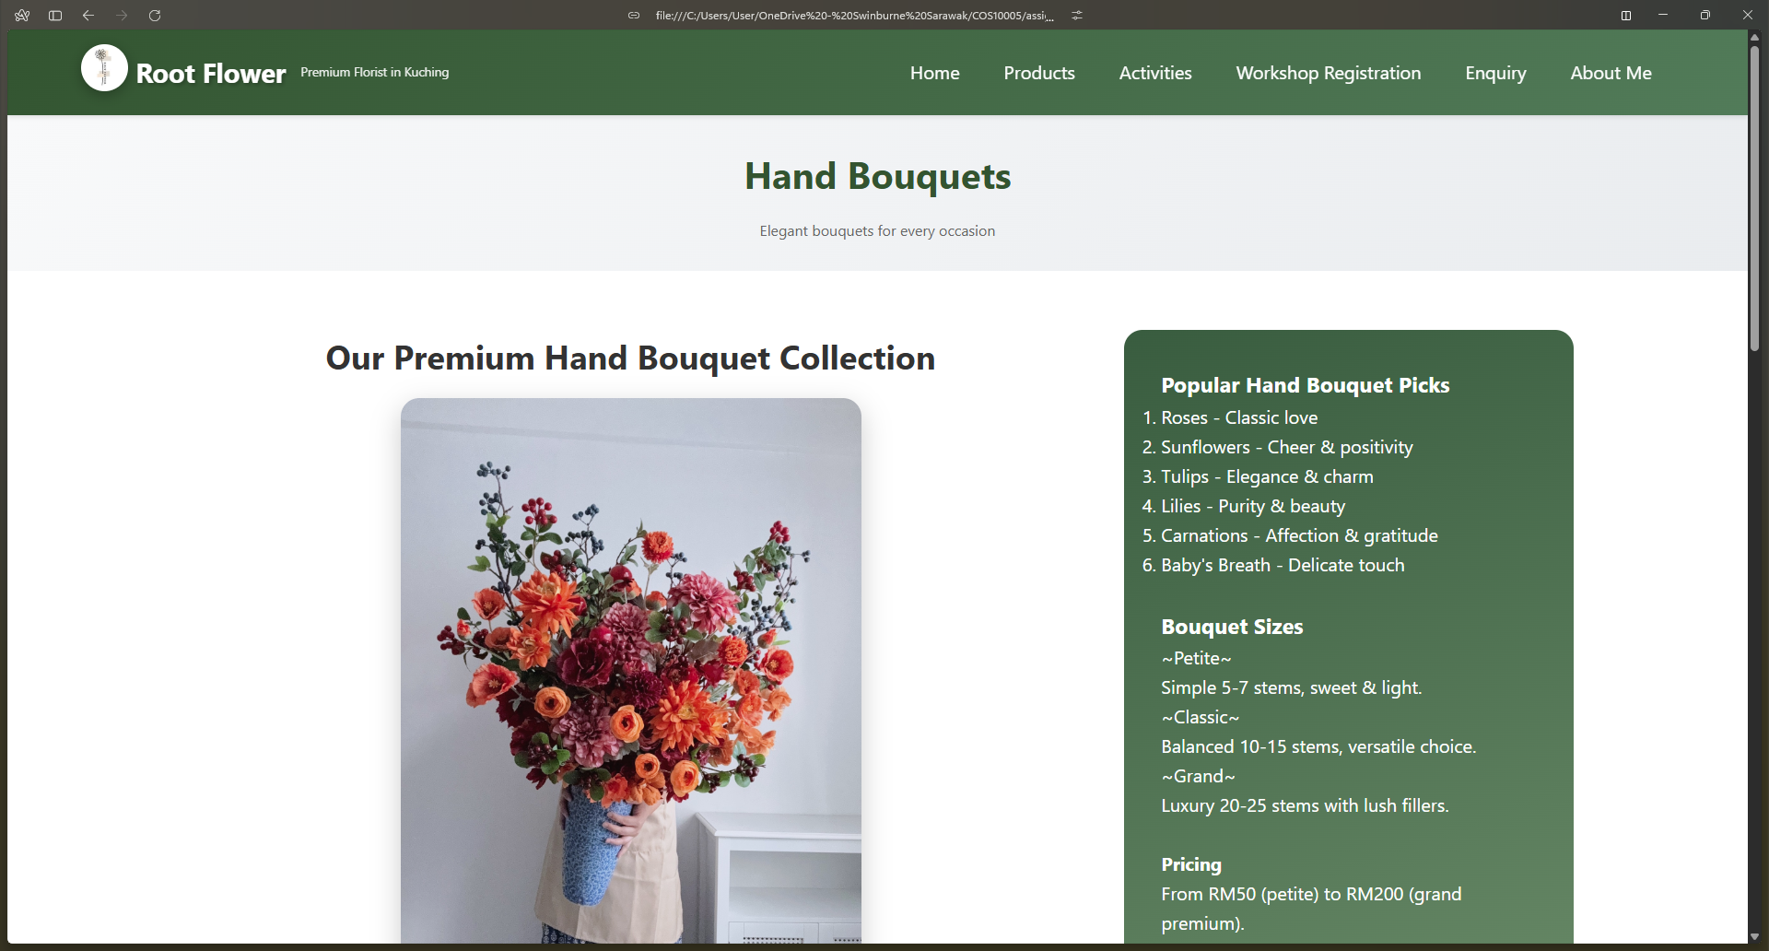

3

6

1

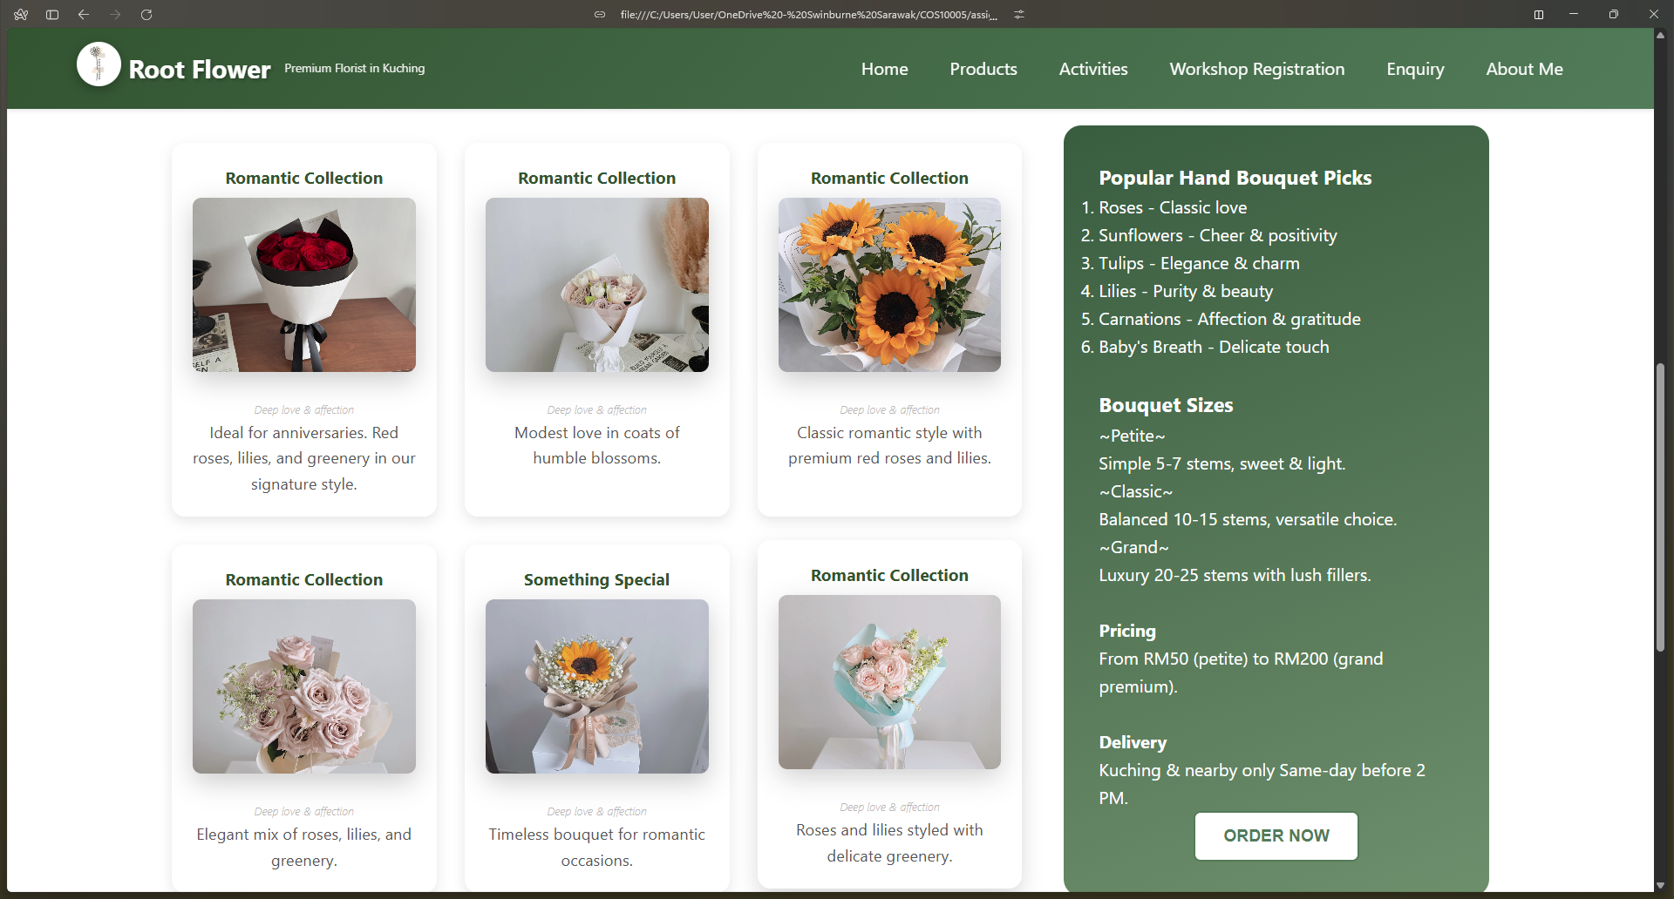

2

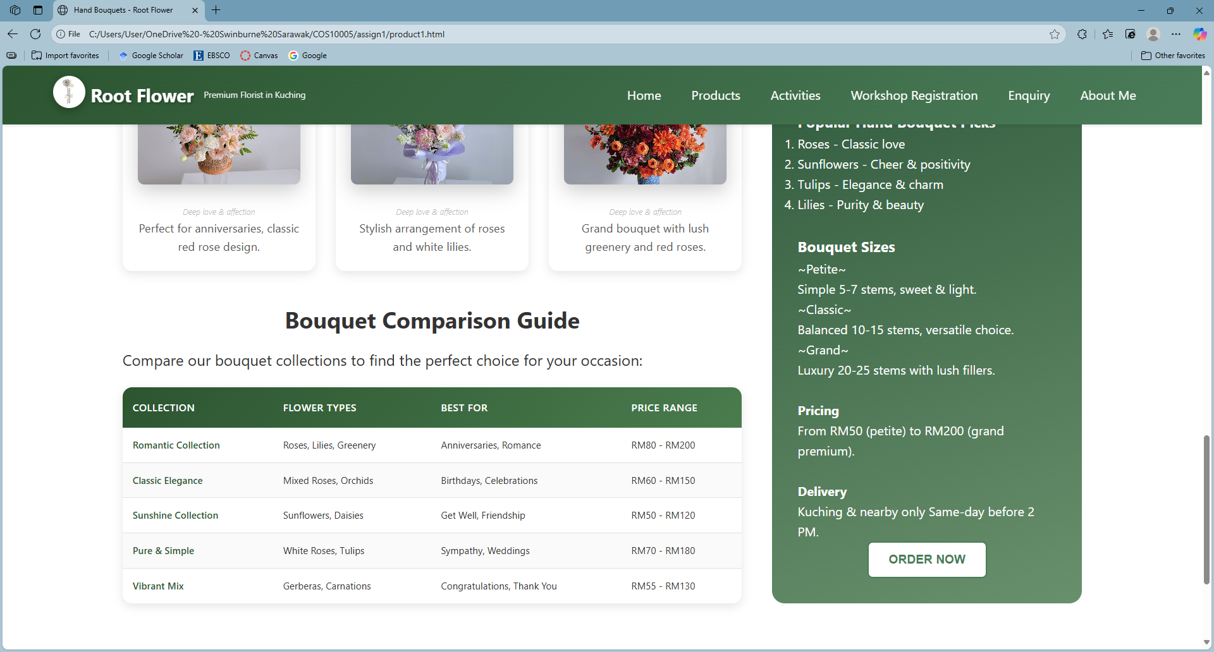

3

5

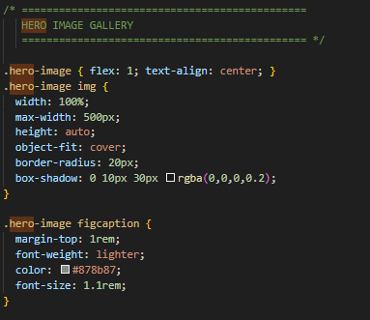 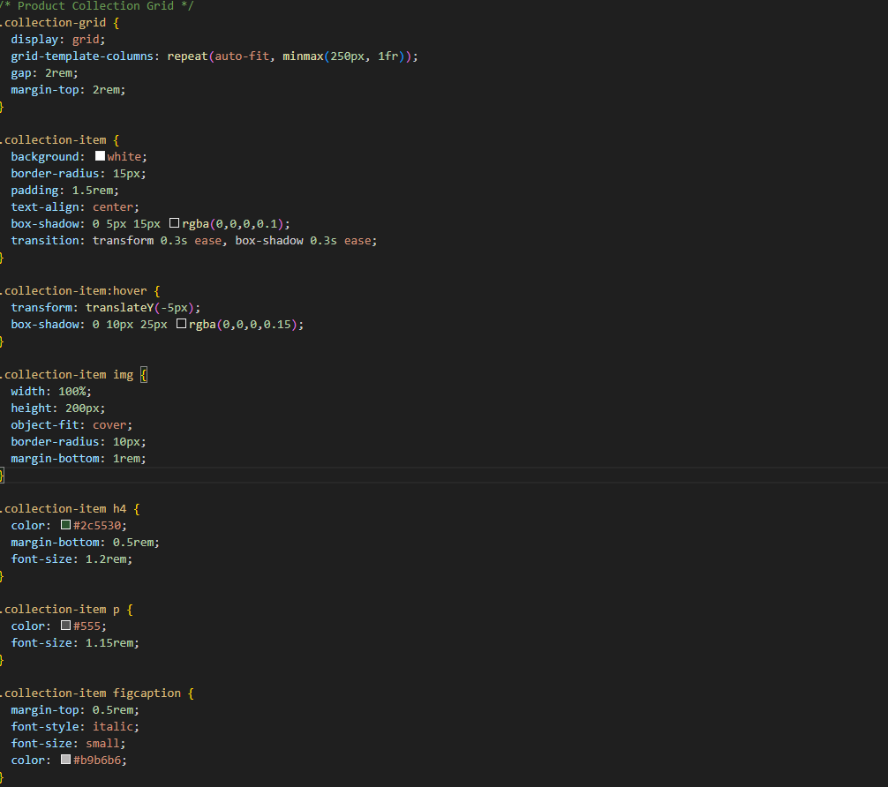

2

1

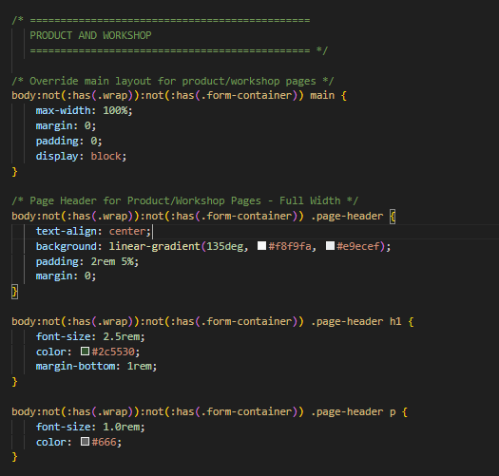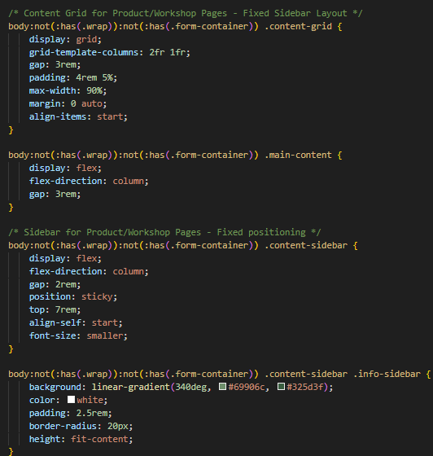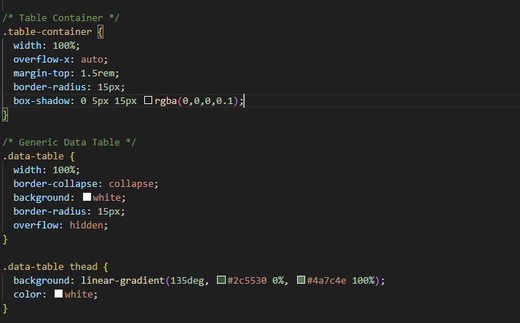

6

3

5

4

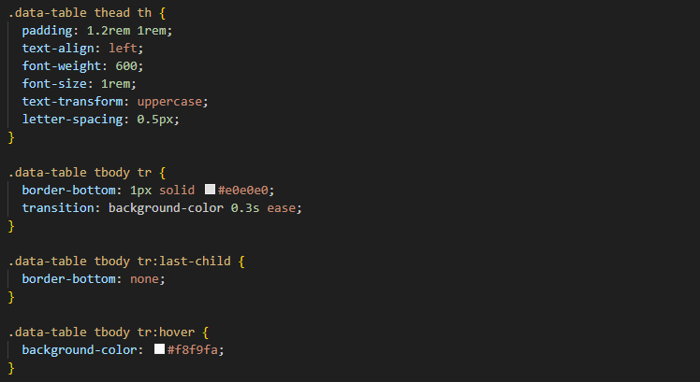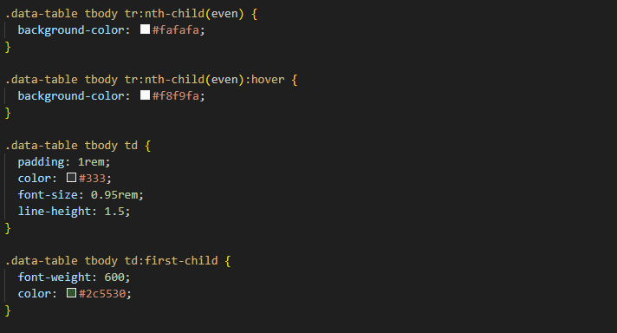

5

|  |  |
| --- | --- |
| No. | Description |
| 1 | Hero image   * hero-image uses flex: 1 and centres content. * Image fully responsive with object-fit: cover. * Rounded corners and soft shadow enhance depth. * figcaption uses top margin, grey text, lighter font weight. |
| 2 | Product collection stylings   * collection-grid uses grid layout with flexible columns and spacing. * margin-top adds space above grid. * collection-item has white background, rounded corners, and centred text. * Hover effect adds interactivity. * Images are responsive, cropped, and have rounded corners. * h4 uses dark green, medium size, and spacing below. * p uses medium grey and balanced font size. * figcaption smaller, light grey, and italicized for contrast. |
| 3 | Page header for product pages (for workshop page too)   * Full-width header with a light-to-dark grey gradient (#f8f9fa → #e9ecef). * Uses padding: 2rem 5% and no external margin. * The h1 is larger (2.5rem), dark green (#2c5530), and separated with margin-bottom. * The paragraph beneath uses smaller grey text (#666) for contrast and clarity. |
| 4 | Layout styling   * content-grid uses two-column grid layout with 3rem gap. * Centred using margin auto, padding, and 90% width limit. * main-content arranged in column direction with vertical spacing. * wrap and form-container stay full-width, no padding or margins. |
| 5 | Table styling   * table-container full width, no horizontal scroll (overflow: hidden). * Rounded corners (15px) with subtle box shadow. * data-table full width, collapses borders, white background. * Rounded corners maintained, overflow hidden for clean edges. * thead gradient background (#2c5530 → #4a7c4e) with white text. * th padded, uppercase, letter-spacing for readability. * tbody tr has bottom border and hover background change. * Even rows slightly lighter for striped effect. * Has hover effect for highlight effect. * td padded, smaller font, dark text color (#333). * First column bold, dark green (#2c5530) for emphasis. |
| 6 | Sidebar styling   * content-sidebar uses vertical flex layout with 2rem gap. * Positioned sticky at top: 7rem for visibility while scrolling. * Text smaller and aligned to top for balance. * info-sidebar styled with green gradient, white text, and padding. * Rounded corners (20px) create a clean, card-like panel. |

## Workshop Page

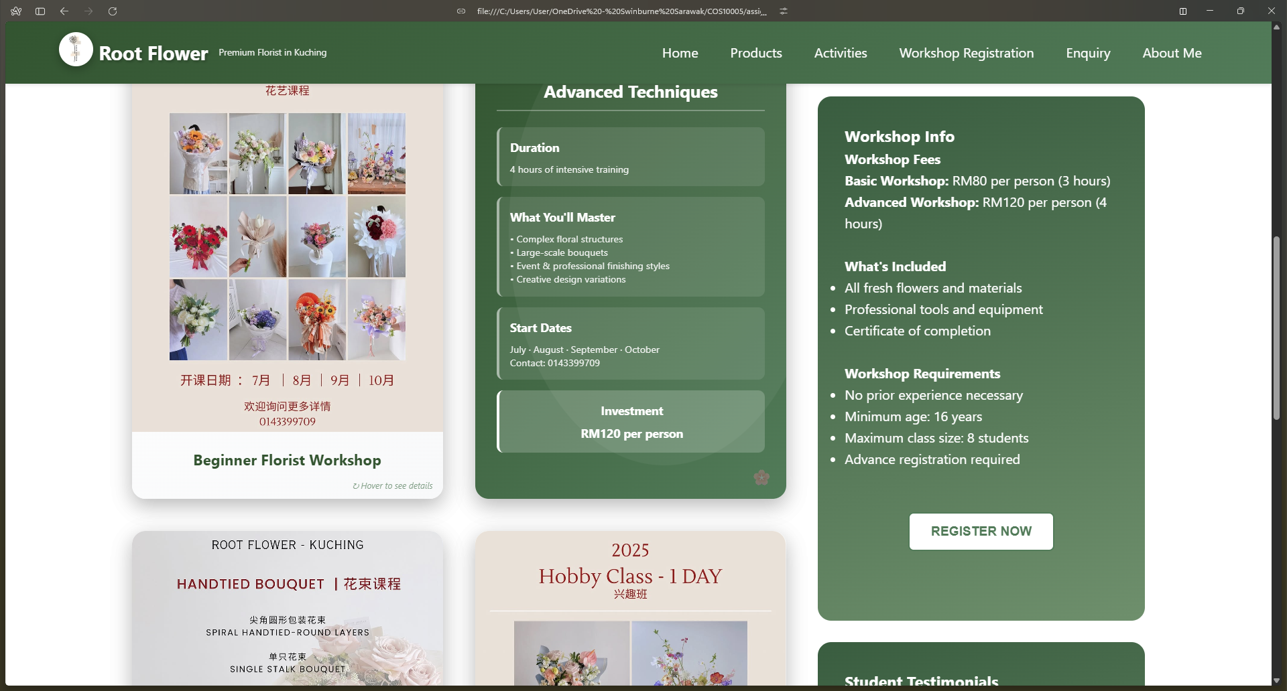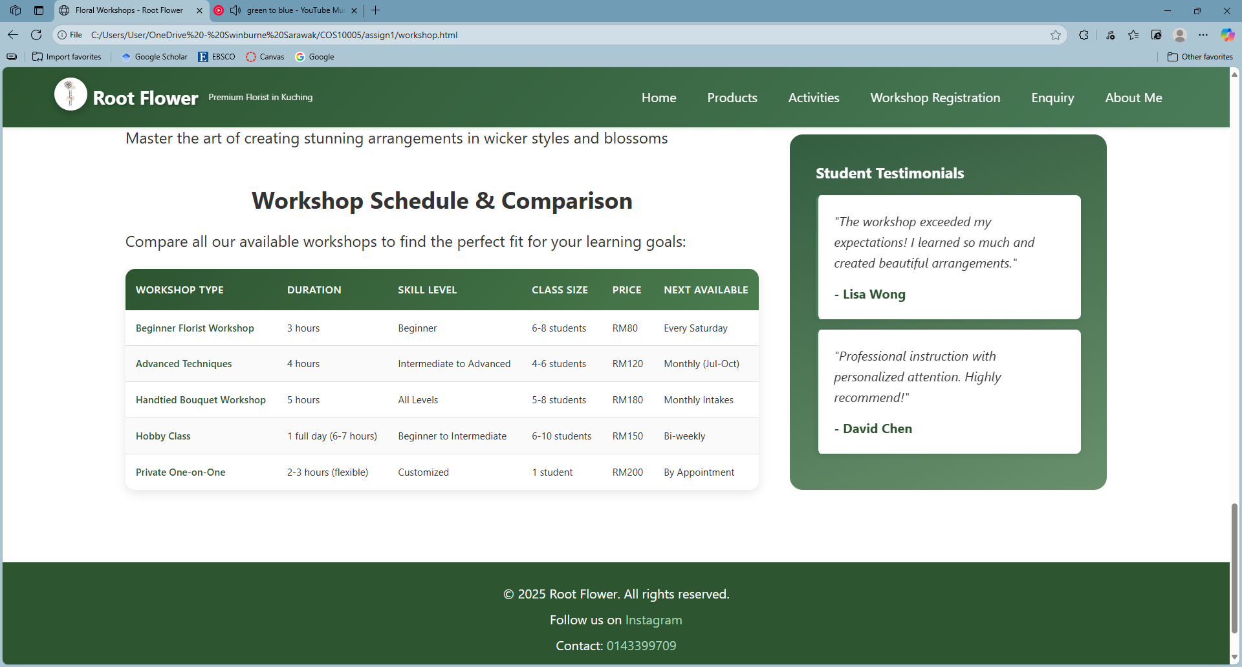

5

5

4

1

3

2

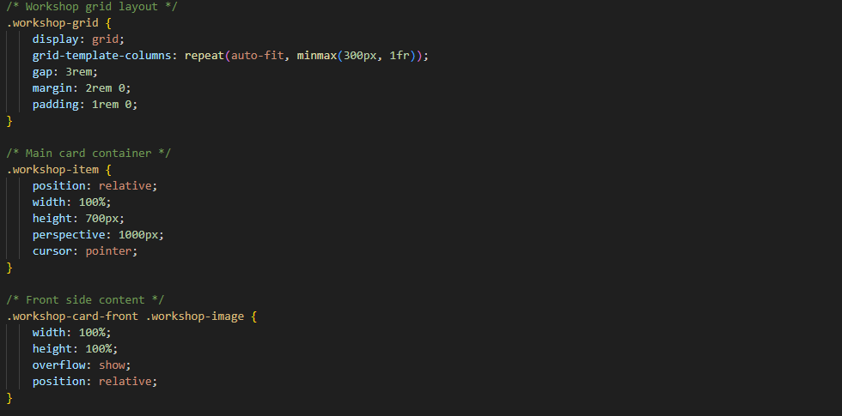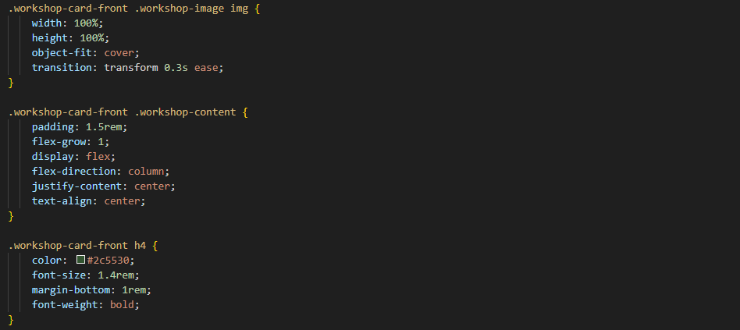

2

2

1

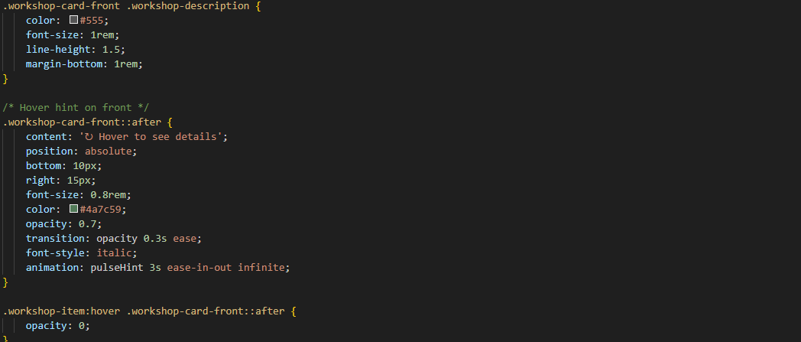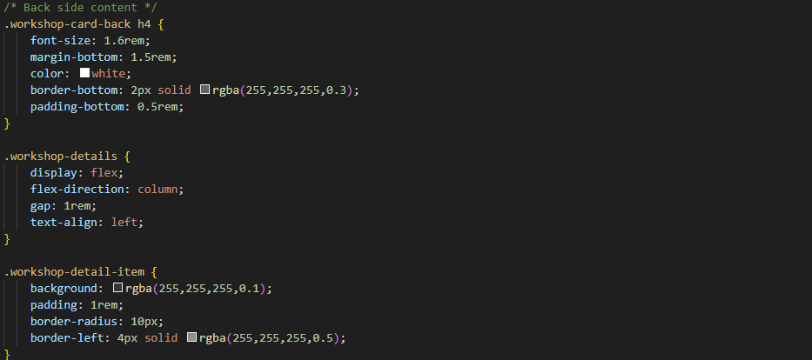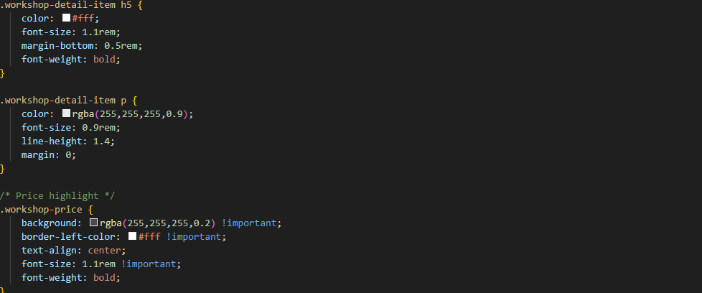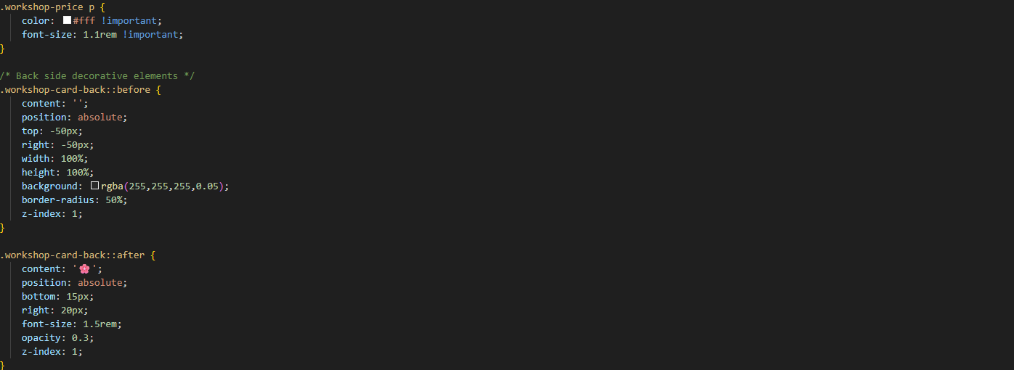

3

3

2

|  |  |
| --- | --- |
| No. | Description |
| 1 | Workshop grid   * workshop-grid uses responsive grid layout with flexible columns. * gap: 3rem ensures even spacing between cards. * Margins and padding provide balanced section spacing. * workshop-item acts as 3D flip card with perspective: 1000px. * Fixed height (700px) and cursor: pointer for interactivity. |
| 2 | Workshop card front   * workshop-image fills container with object-fit: cover. * Smooth animation via transition: transform 0.3s ease. * workshop-content centred using flex layout and padding. * h4 styled dark green, bold, 1.4rem, spaced below. * workshop-description soft grey, 1rem, readable line height. * Hover hint shows “↻ Hover to see details” with fade-out effect. |
| 3 | Workshop card back   * workshop-details uses flex column layout with 1rem gap. * workshop-detail-item has translucent background and white accent border. * h5 bold white, 1.1rem, with slight spacing. * p soft white, smaller font, compact line height. * workshop-price highlighted with light background and bold centred text. * Decorative glow (::before) and flower icon (::after) add subtle style. |
| 4 | Table styling   * Same styling as product page table. |
| 5 | Sidebar styling   * Same styling as product page sidebar. * The blockquote styling is the same as the one used in testimonial section in homepage. |

## Promotion Page

Promotion page utilises a scrolling gallery style.

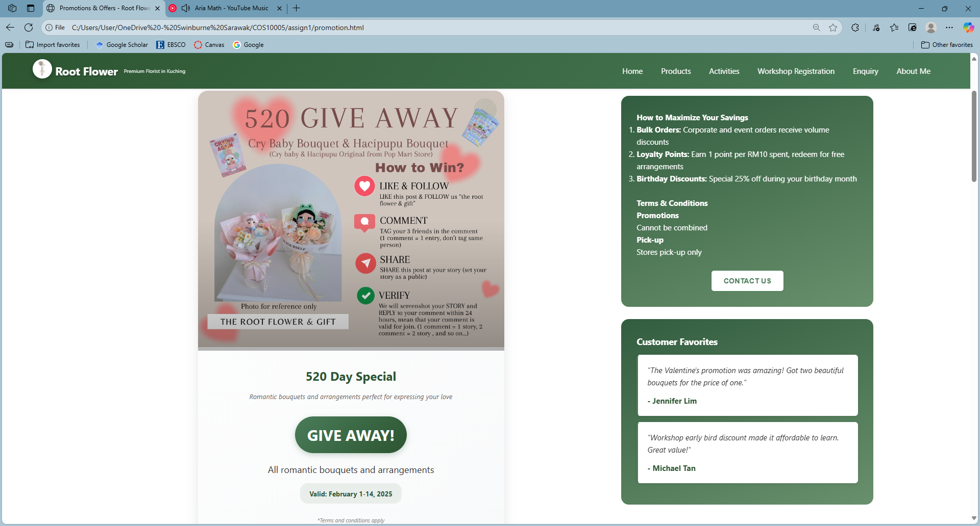

3

2

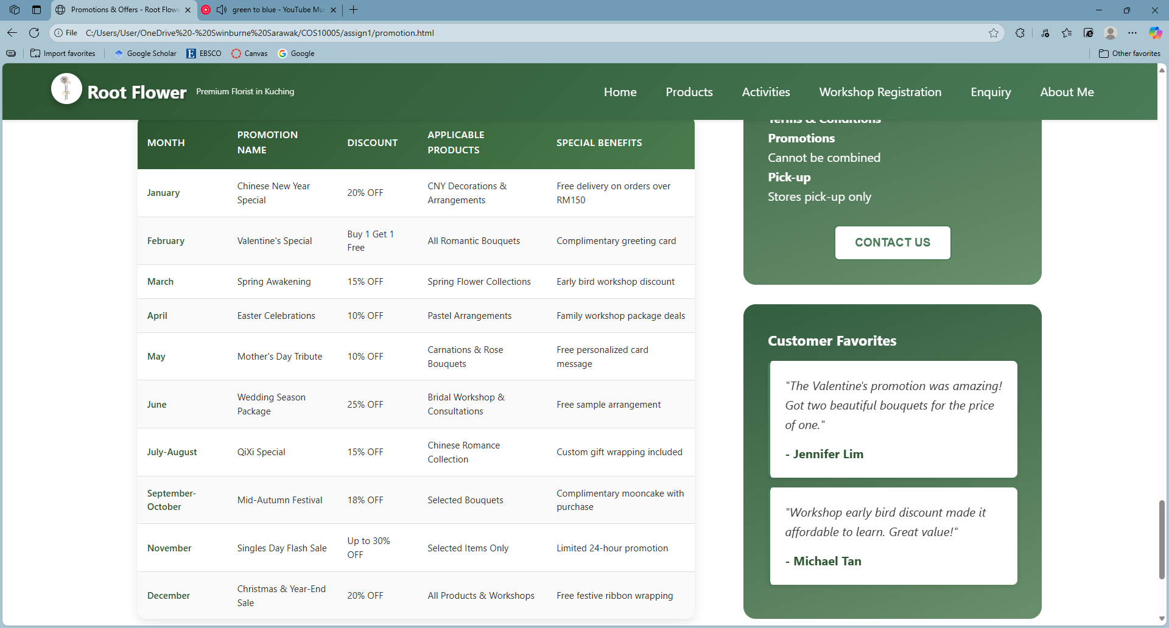

5

4

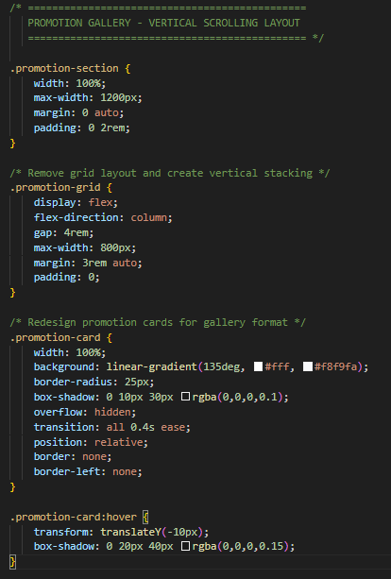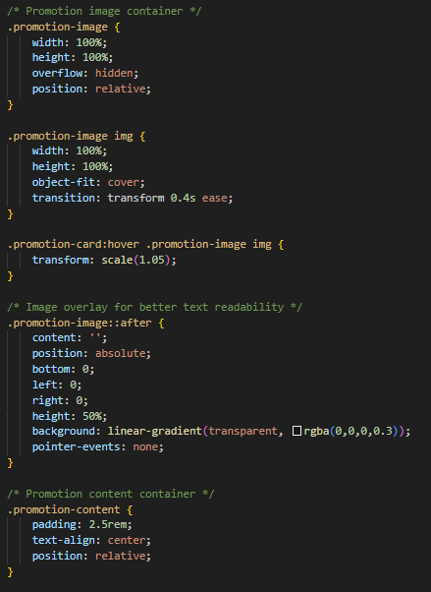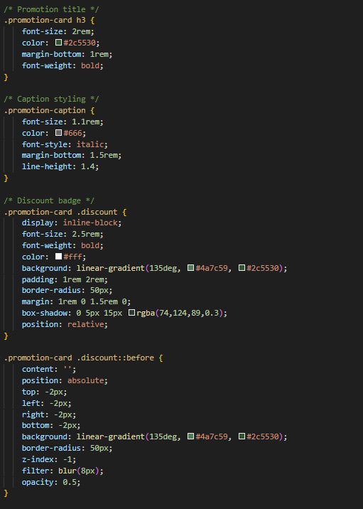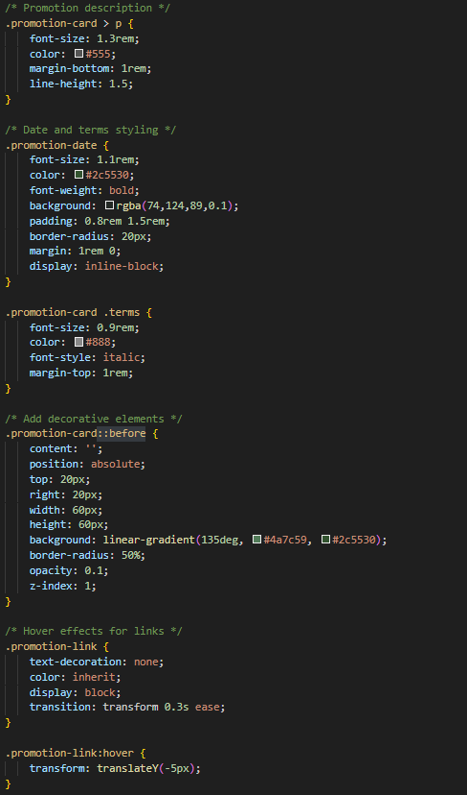

3

3

2

2

1

|  |  |
| --- | --- |
| No. | Description |
| 1 | Promotion section   * promotion-section spans full width, max-width: 1200px. * Centred with margin: 0 auto, padded 0 2rem. * promotion-grid uses flex column layout with 4rem gap. * Centred alignment, margin: 3rem auto, max-width: 800px. |
| 2 | Promotion card   * promotion-card spans full width with gradient (#fff → #f8f9fa). * Rounded corners (25px) and light box shadow for depth. * Uses overflow: hidden, relative position, and 0.4s transition. * promotion-image positioned relative, full width, overflow hidden. * Images use object-fit: cover with smooth 0.4s transition. * Dark gradient overlay adds lower-half contrast. |
| 3 | Promotion content   * promotion-content centres text, adds 2.5rem padding, relative position. * Headings (h3) bold, 2rem, dark green (#2c5530), with bottom spacing. * promotion-caption italic, grey (#666), 1.1rem, margin-bottom: 1.5rem. * Paragraphs 1.3rem, medium grey (#555), line-height: 1.5. * promotion-date bold dark green text, semi-transparent green background, pill shape. * terms small (0.9rem), light grey (#888), italic, margin-top: 1rem. * discount badge green gradient (#4a7c59 → #2c5530), bold white text, 2.5rem, rounded pill, soft glow. * promotion-card::before adds faint green gradient circle at top-right. * promotion-link removes underline, makes full card clickable with hover transition. |
| 4 | Table styling   * Same styling as product page table. |
| 5 | Sidebar styling   * Same styling as product page sidebar. * The blockquote styling is the same as the one used in testimonial section in homepage. |

## Workshop Registration & Enquiry Page

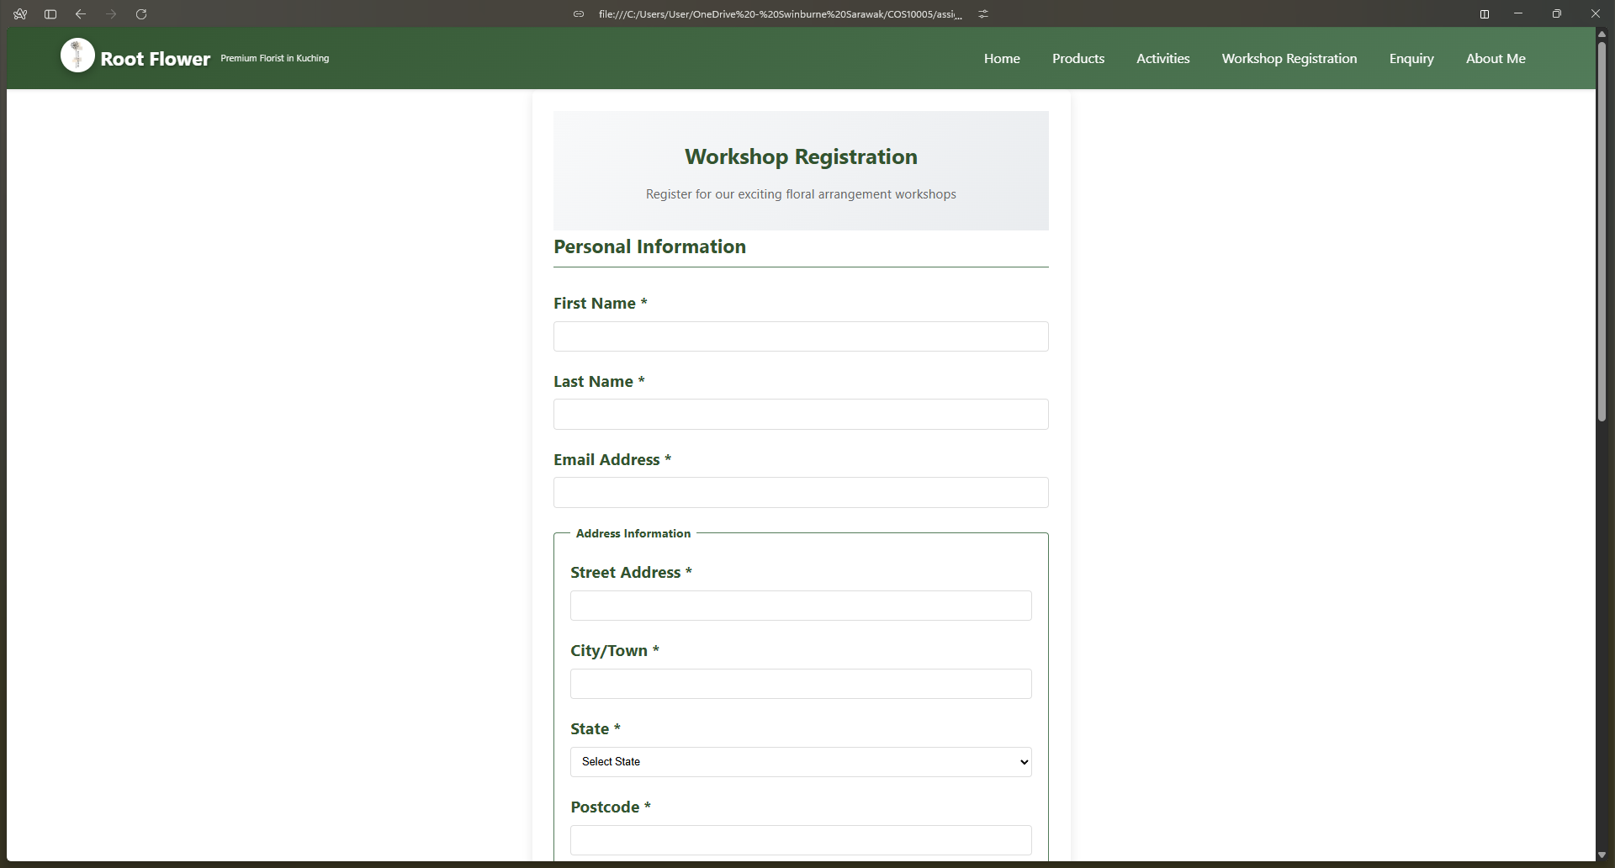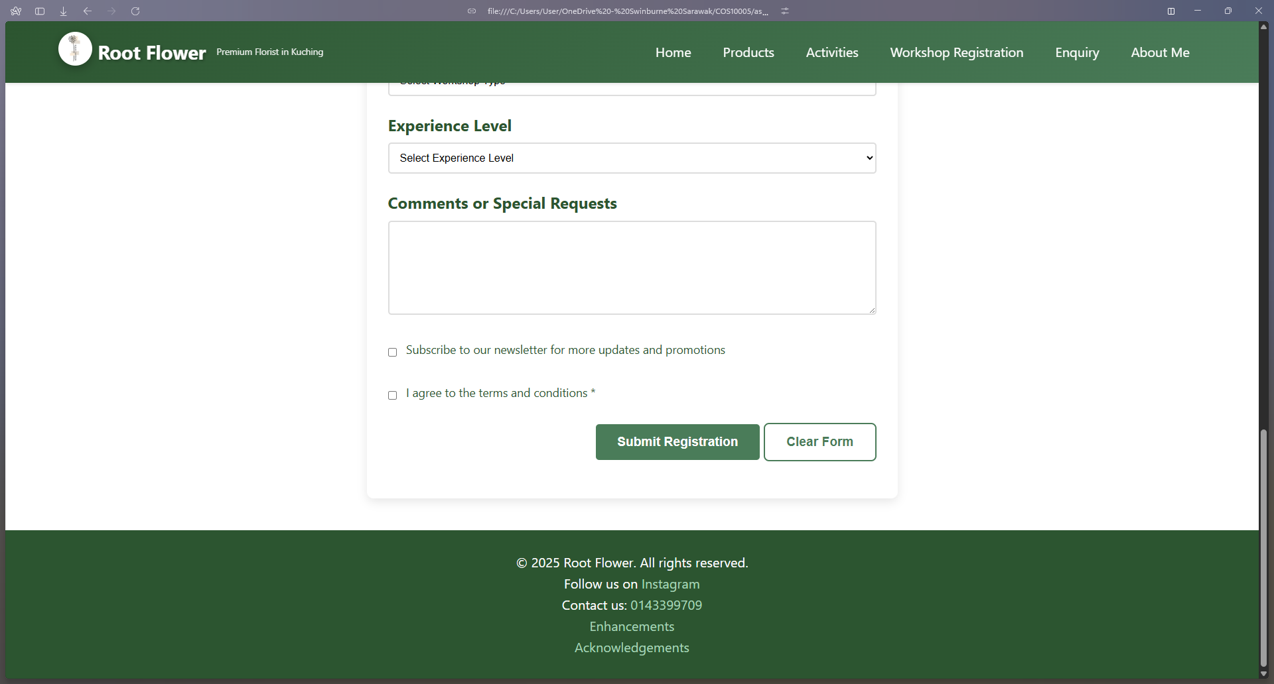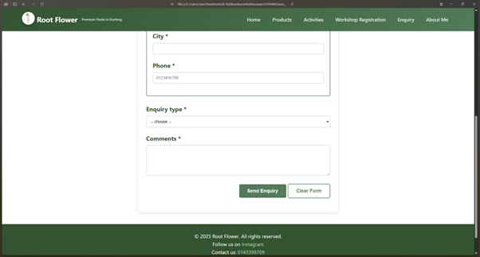

1

3

2

4

3

2

1

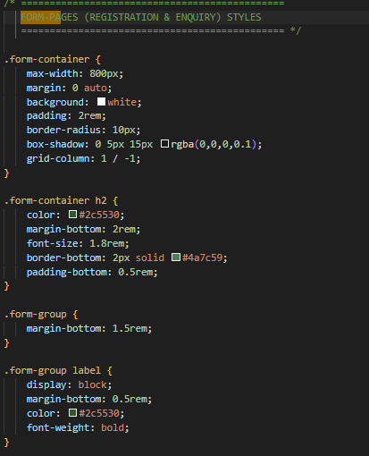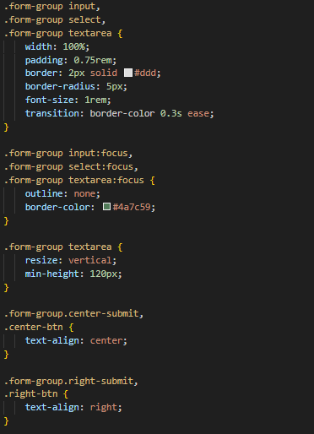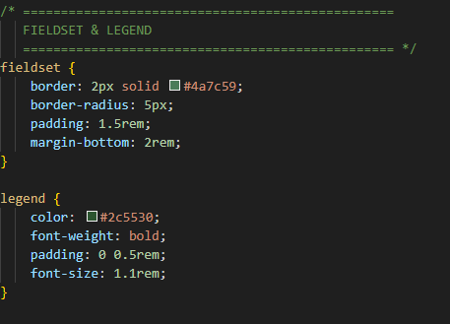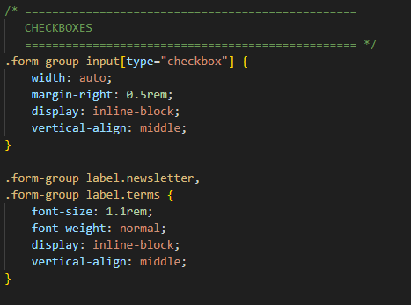

4

3

2

2

1

|  |  |
| --- | --- |
| No. | Description |
| 1 | Form container   * form-container centred with margin: 0 auto, max-width: 800px. * White background, 2rem padding, rounded corners (10px), soft shadow. * h2 headings dark green (#2c5530), 1.8rem, underlined with #4a7c59 border. * Headings spaced with 2rem bottom margin, 0.5rem padding. * form-group separated by 1.5rem bottom margin for clarity. |
| 2 | Label and Input Styling   * form-group labels shown as block elements, margin-bottom: 0.5rem, bold, dark green. * Inputs, selects, textareas share full-width layout with padding, rounded borders. * Borders transition smoothly on focus, changing to deep green (#4a7c59). * Textareas resize vertically, min-height: 120px for consistency. * Button alignment classes use text-align for proper positioning. |
| 3 | Fieldset and Legend   * fieldset uses 2px green border, rounded corners, and inner padding. * margin-bottom: 2rem adds clear spacing between sections. * legend text is dark green, bold, 1.1rem, with side padding for emphasis. |
| 4 | Checkboxes and Inline Labels   * Checkboxes sized auto, spaced with 0.5rem right margin. * Aligned vertically middle for neat inline positioning. * Labels use inline-block, 1.1rem font, normal weight, and vertical alignment. |

## Profile Page

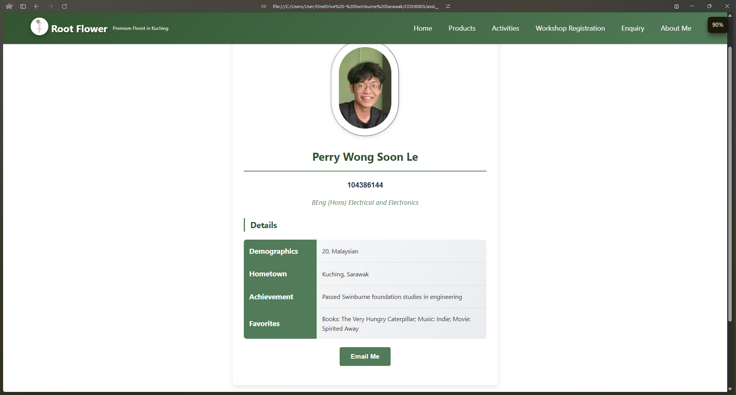

4

3

2

1

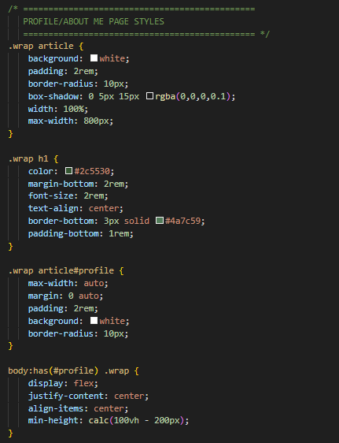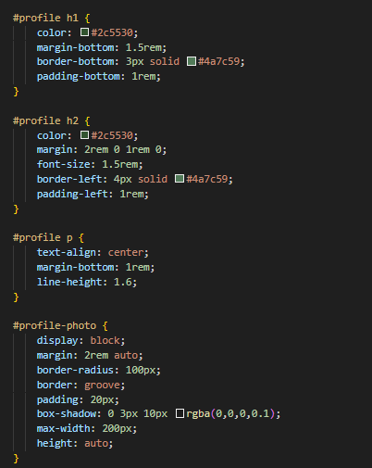

2

1

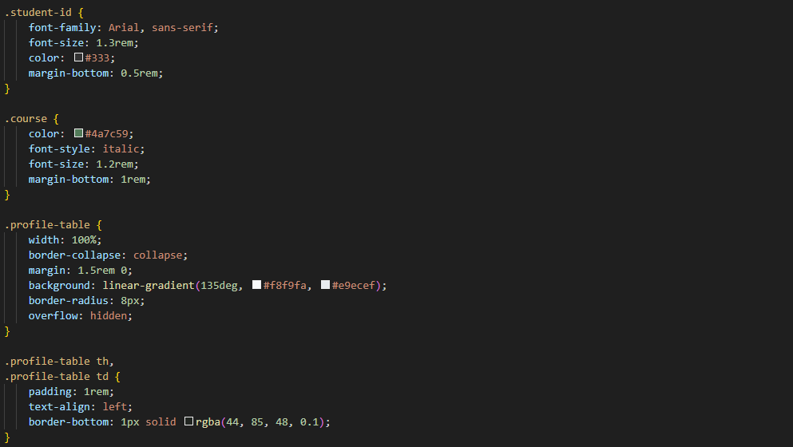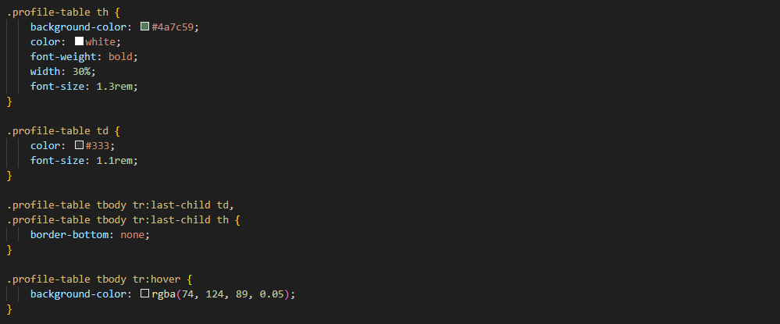

4

4

3

|  |  |
| --- | --- |
| No. | Description |
| 1 | Wrap container   * wrap structures layout for the profile page section. * Articles have white background, padding, rounded corners, and soft shadow. * Full width with 800px max-width ensures text readability. * Headings centred, dark green, and underlined with solid border. * body:has(#profile) .wrap centres content using flex layout. |
| 2 | Profile block   * #profile uses white background, padding, and rounded corners. * Main heading is dark green with bottom solid border. * Subheadings have left green border and padded spacing. * Paragraphs centred, spaced, and use 1.6 line-height. |
| 3 | Profile photo and identity styling   * #profile-photo is centred with block display and auto margins. * Rounded edges, soft shadow, max-width 200px, height auto. * student-id shows dark grey text, sans-serif, 1.3rem font. * course uses italic green text, 1.2rem, spaced below. |
| 4 | Table styling   * profile-table uses full width with collapsed borders and gradient background. * Rounded corners and hidden overflow ensure smooth table edges. * Table headers have dark green background, white bold text, 1.3rem font. * Data cells use #333 text, 1.1rem, with subtle bottom borders. * Row hover adds faint green tint for better readability. |

## Enhancement Page

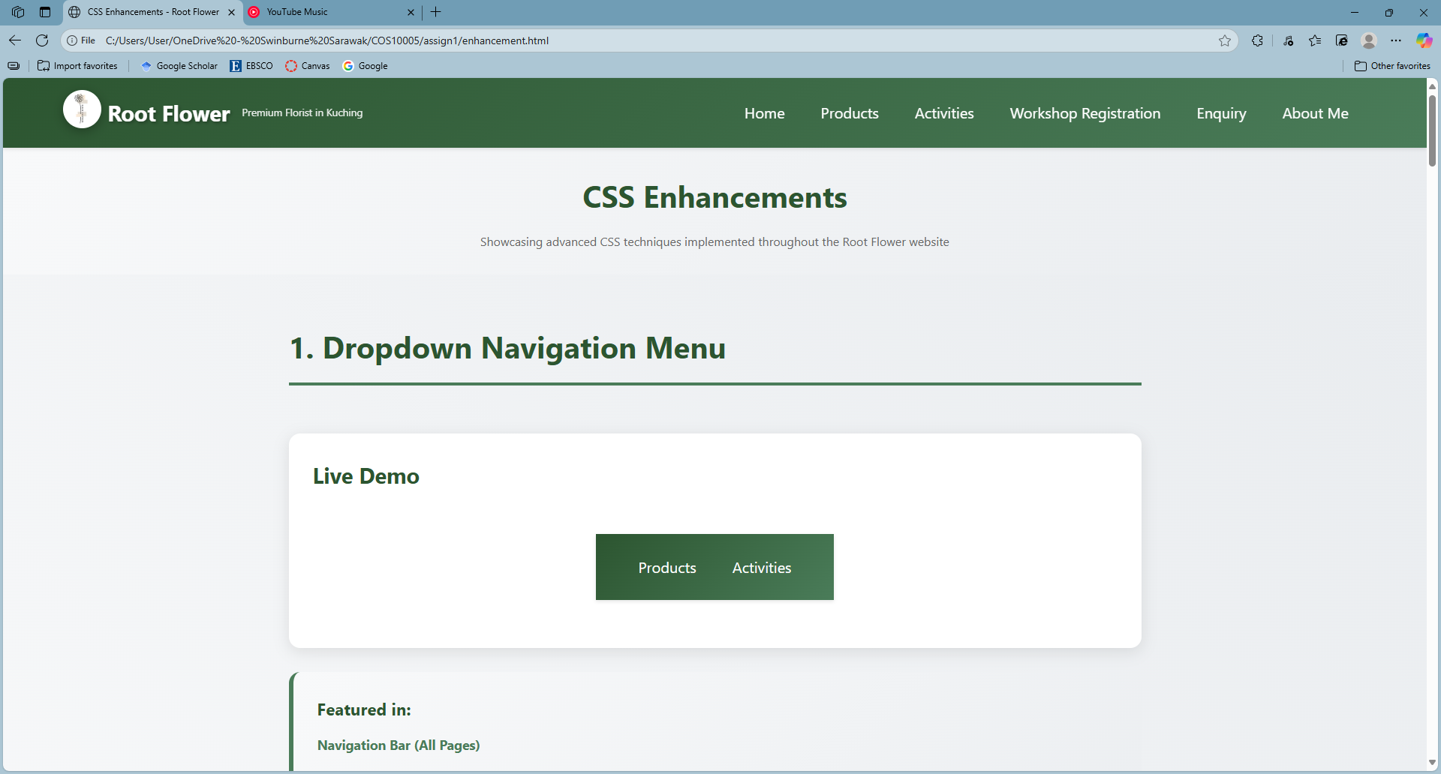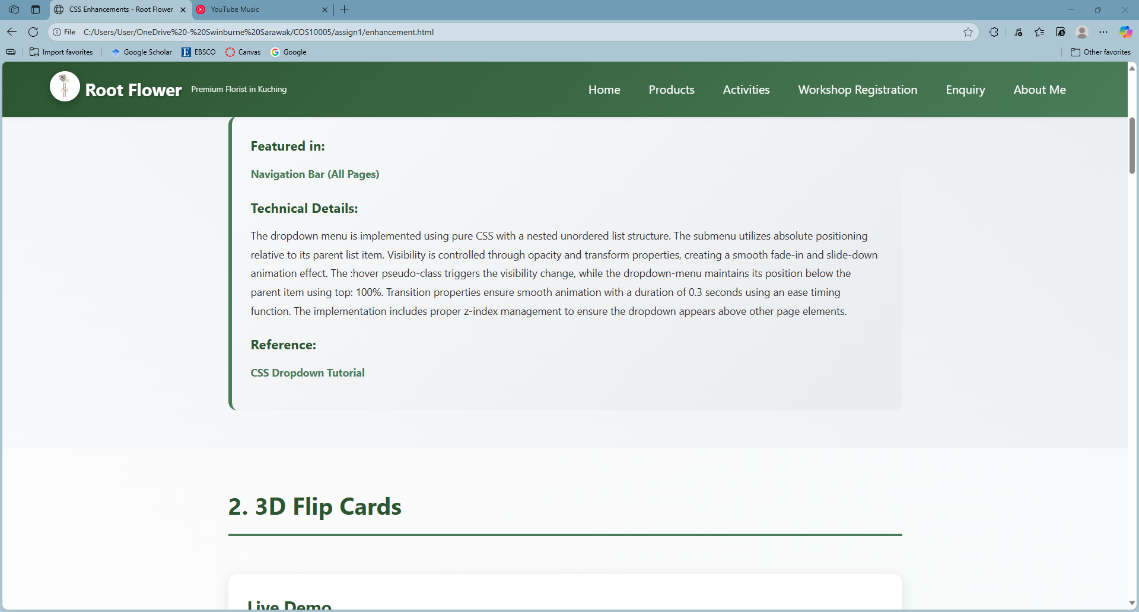

3

2

1

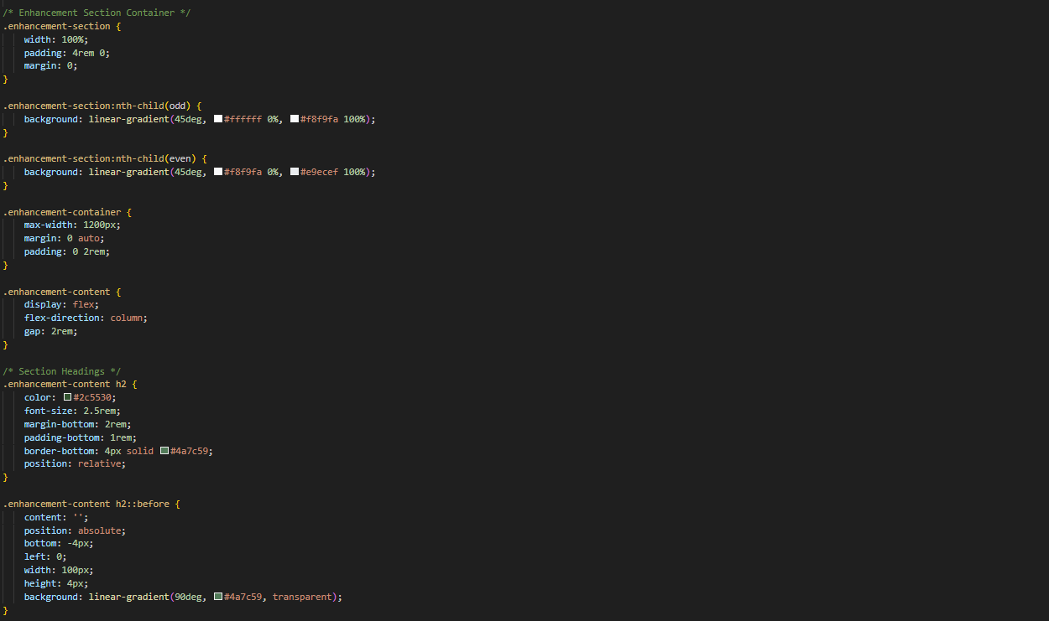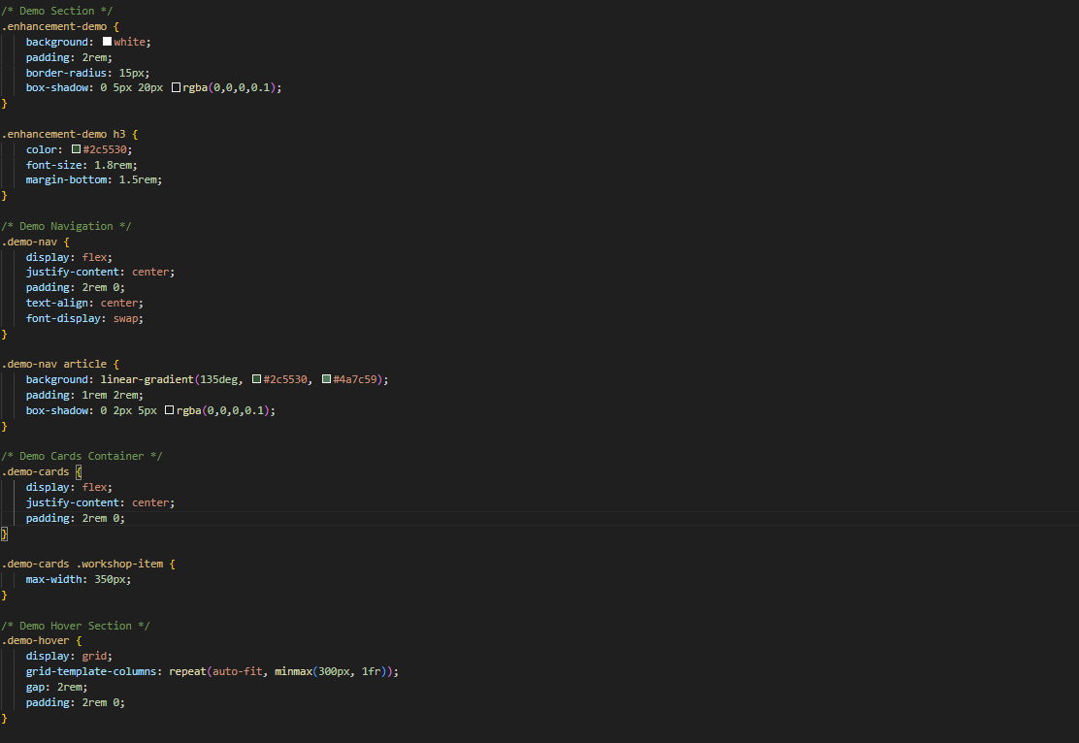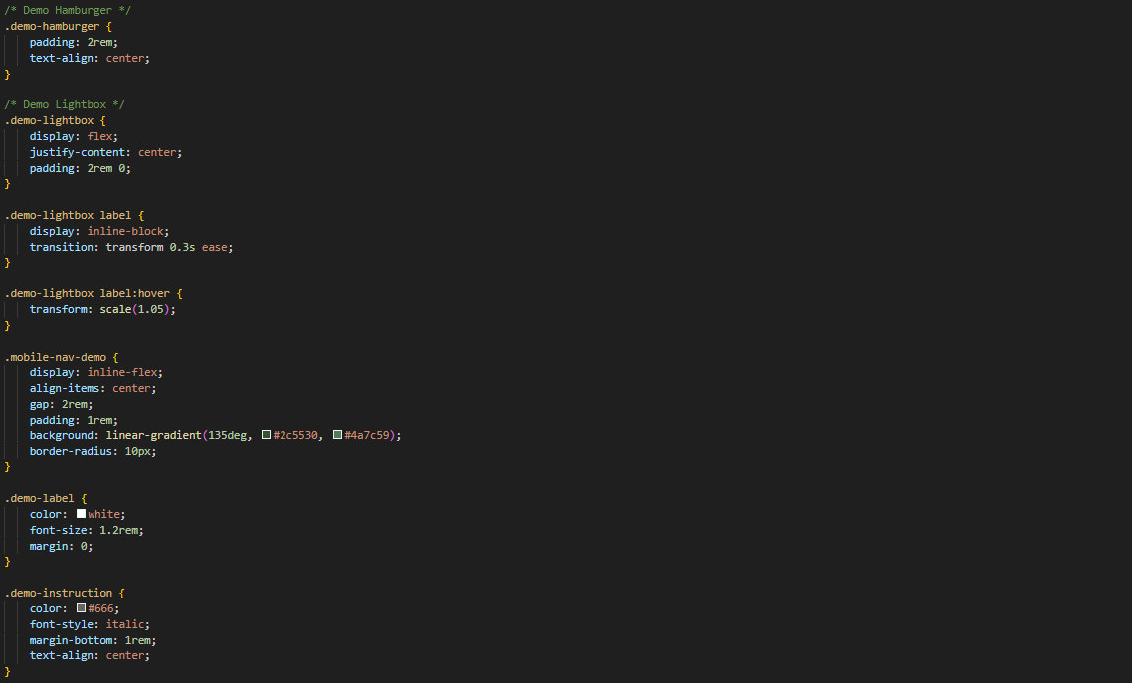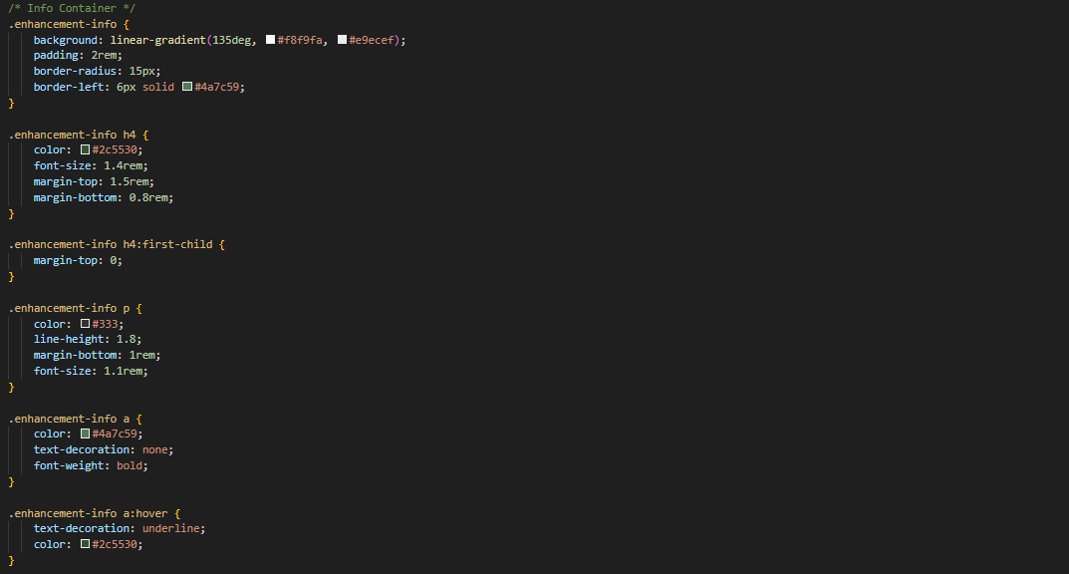

3

2

2

1

|  |  |
| --- | --- |
| No. | Description |
| 1 | Enhancement section general styling   * enhancement-section full width, vertical padding 4rem. * Odd sections use light gradient (#fff → #f8f9fa). * Even sections use slightly darker gradient (#f8f9fa → #e9ecef). * enhancement-container limits width to 1200px, centres content. * Horizontal padding (2rem) for smaller screens. * enhancement-content uses vertical flex layout with 2rem gap. * h2 headings dark green (#2c5530), 2.5rem font size. * Bottom padding 1rem with 4px green border underlines heading. * Decorative ::before line 100px wide, gradient green fade effect. * Alternating background improves visual separation between sections. * Flex layout ensures consistent spacing for demo and info blocks. |
| 2 | Enhancement demo styling   * enhancement-demo white background, 2rem padding, rounded 15px corners. * Box shadow for subtle depth (0 5px 20px rgba). * h3 headings dark green (#2c5530), font-size 1.8rem, margin-bottom 1.5rem. * demo-nav uses flex, centres content, 2rem vertical padding. * demo-nav article gradient background (#2c5530 → #4a7c59), padding 1rem 2rem. * demo-cards flex container, centres workshop items, max width 350px. * demo-hover uses responsive grid (min 300px), 2rem gap. * demo-hamburger centred padding 2rem. * demo-lightbox flex, centred content, 2rem vertical padding. * Lightbox labels scale on hover (1.05x). * mobile-nav-demo inline-flex, gap 2rem, gradient background, 10px radius. * demo-label white text, 1.2rem font. * demo-instruction grey italic text, centred below demo. |
| 3 | Enhancement details styling   * enhancement-info gradient background (#f8f9fa → #e9ecef), 2rem padding. * Rounded corners (15px) and left border (6px, #4a7c59). * h4 headings dark green (#2c5530), font-size 1.4rem, spaced vertically. * First h4 has no top margin. * Paragraphs (p) dark grey (#333), line-height 1.8, font-size 1.1rem. * Links (a) dark green (#4a7c59), bold, no underline by default. * Link hover: underline appears, colour changes to darker green (#2c5530). |

## Acknowledgement Page

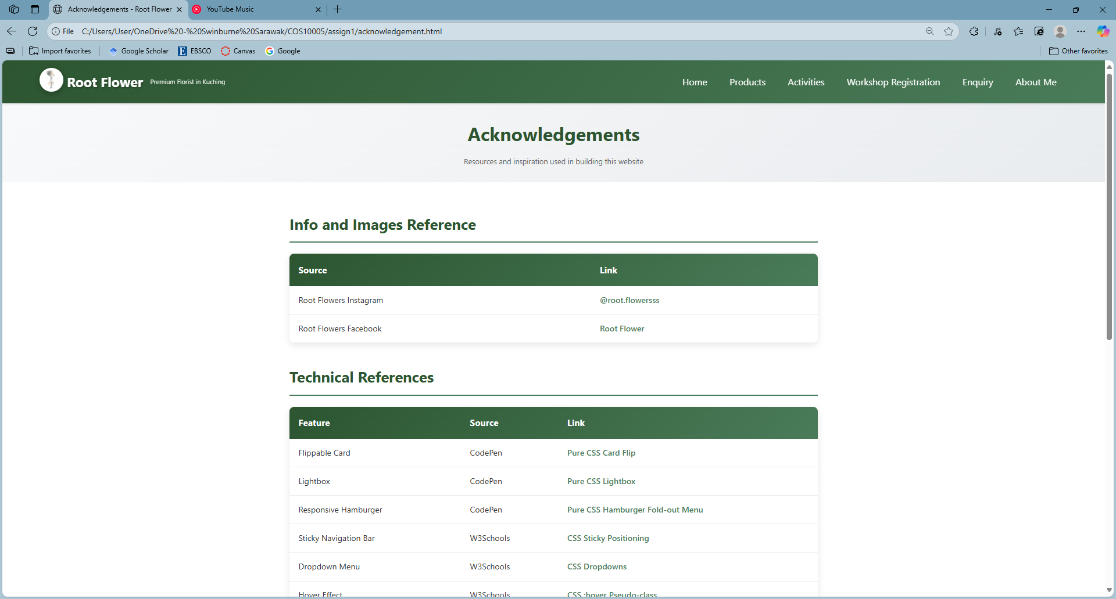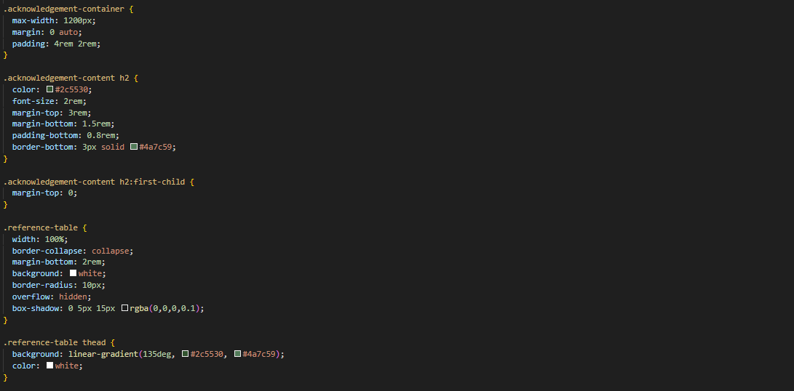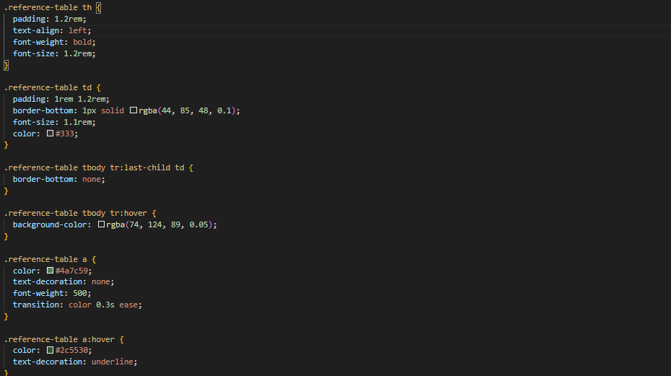

1

2

2

|  |  |
| --- | --- |
| No. | Description |
| 1 | Acknowledgement section styling   * acknowledgement-container centres content, padding 4rem top/bottom, 2rem sides. * h2 headings dark green (#2c5530), font-size 2rem, spaced with margins. * h2 first child has no top margin. * Border-bottom on headings: 3px solid #4a7c59. |
| 2 | Acknowledgement references table styling   * reference-table full-width, white background, rounded corners (10px), shadowed. * Table header gradient (#2c5530 → #4a7c59) with white text. * th padding 1.2rem, bold, 1.2rem font size. * td padding 1–1.2rem, bottom border light green, font-size 1.1rem, dark text. * Last row has no bottom border. * Row hover: subtle green background. * Links inside table: green (#4a7c59), bold, underline on hover, colour darkens (#2c5530). |

# Key features

This section outlines the CSS enhancements in the website, all made without JavaScript.

## Dropdown menu

The dropdown menu expands the parent menu and shows the submenu when hovered upon, improving user interactivity.

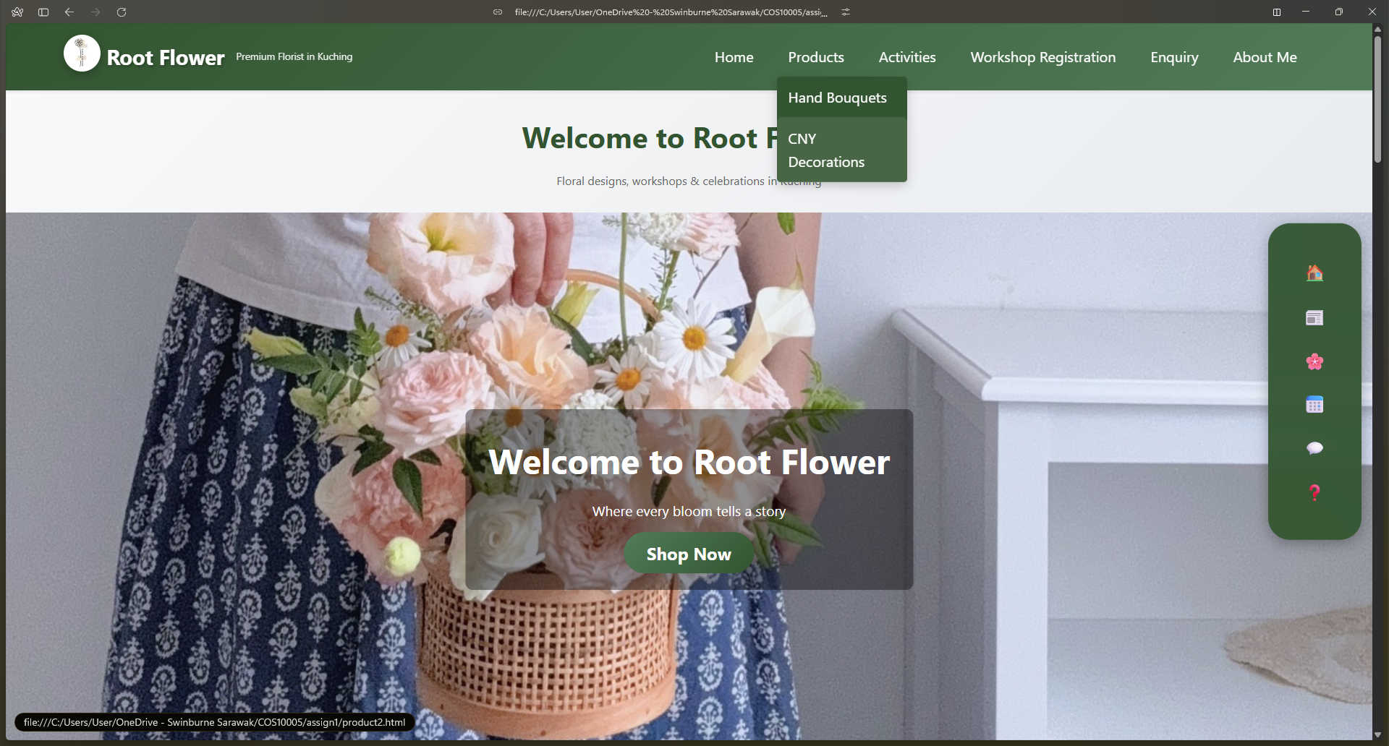

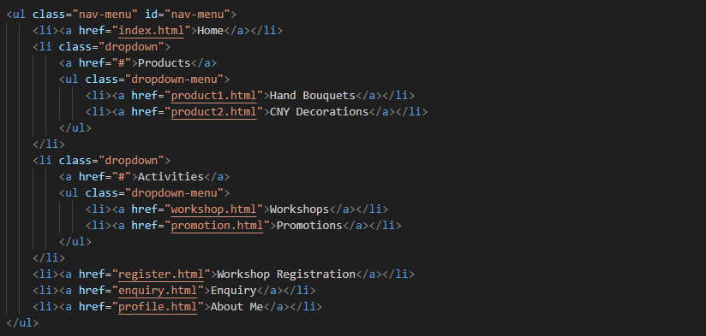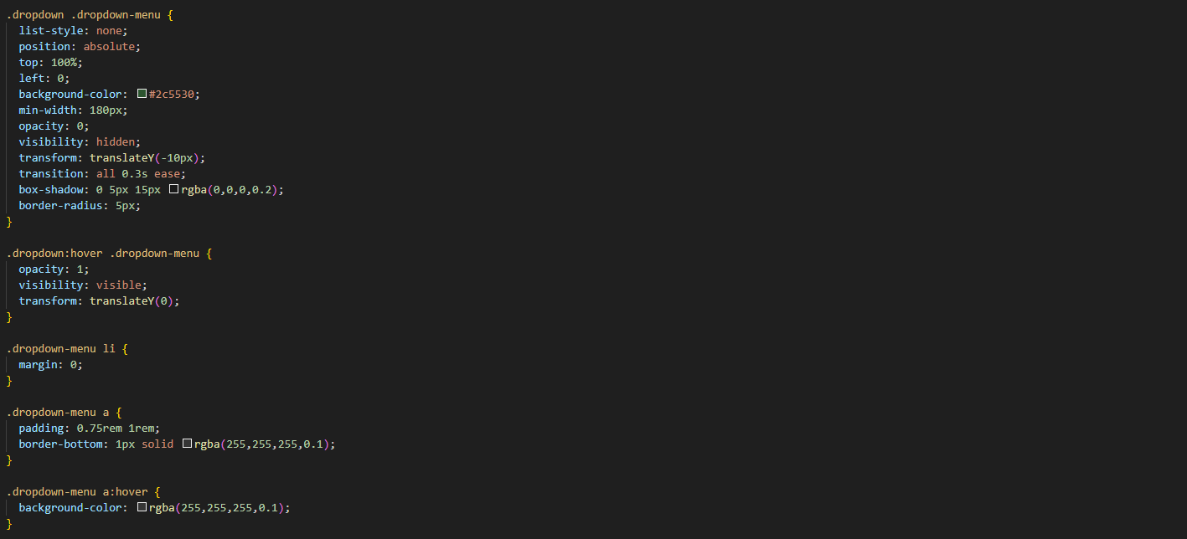

2

3

1

|  |  |
| --- | --- |
| No. | Description |
| 1 | HTML section   * Navigation uses ul class="nav-menu" with primary links. * Products and Activities have dropdown class for submenus. * Dropdowns contain nested ul class="dropdown-menu" with related links. * Two-level system lets top items expand to show secondary links. |
| 2 | Dropdown visibility and animation   * Each dropdown-menu is positioned absolutely below its parent. * Initially hidden with opacity 0, visibility hidden, and translateY(-10px). * On hover, submenu shows up with opacity 1, visibility visible, translateY(0). * Transitions on opacity and transform create smooth fade-and-slide animation. |
| 3. | Dropdown appearance   * dropdown uses dark green background (#2c5530) with rounded corners. * Soft box shadow creates a floating panel effect. * Menu items stacked vertically with no margins for compact spacing. * Links have padding and thin white borders separating each option. * On hover, links brighten slightly with semi-transparent background for feedback. |

## Sticky nav

The sticky navigation enhancement allows the navigation bar to stay on top no matter the scrolling of webpage. This enables users to access the links to various pages always.

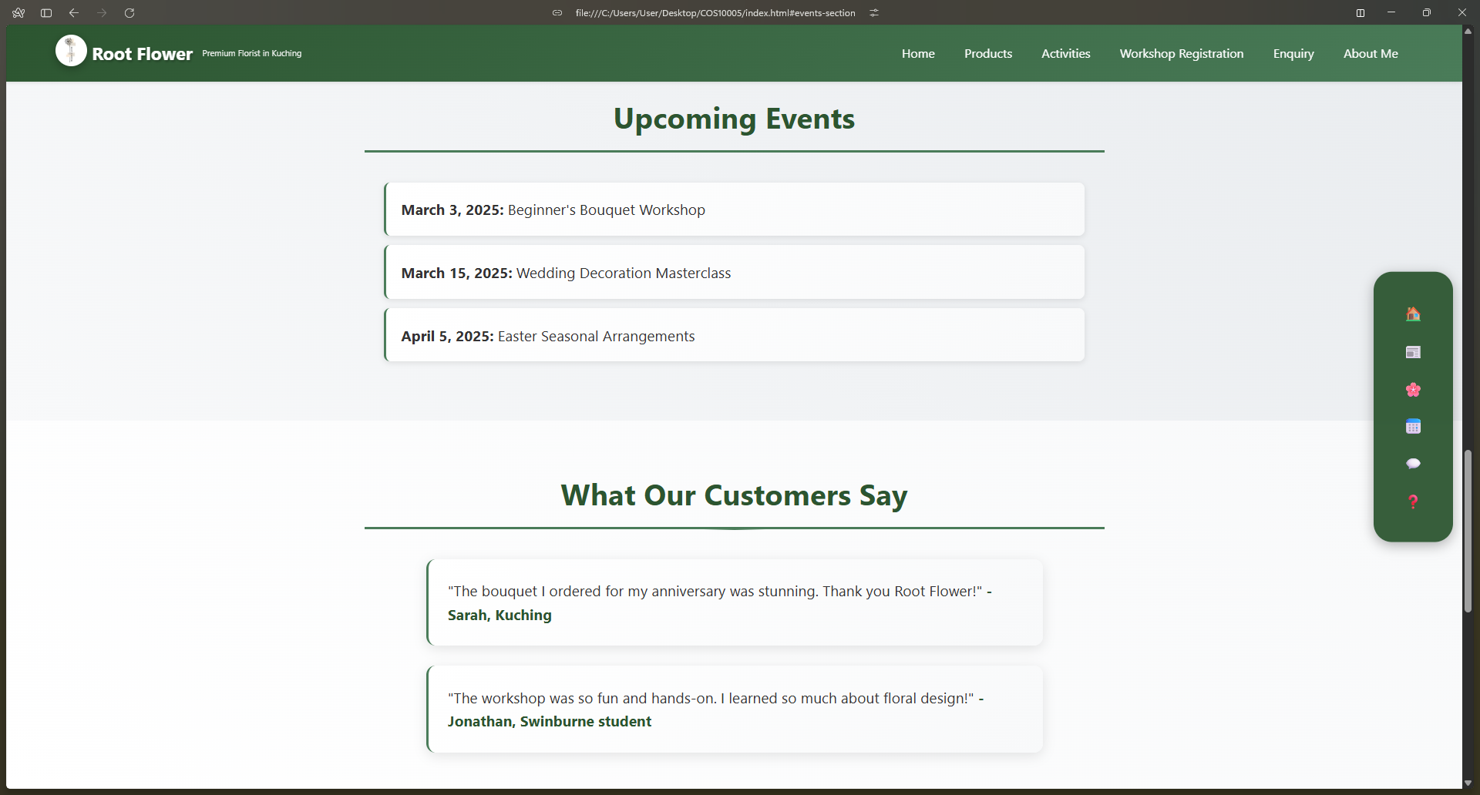

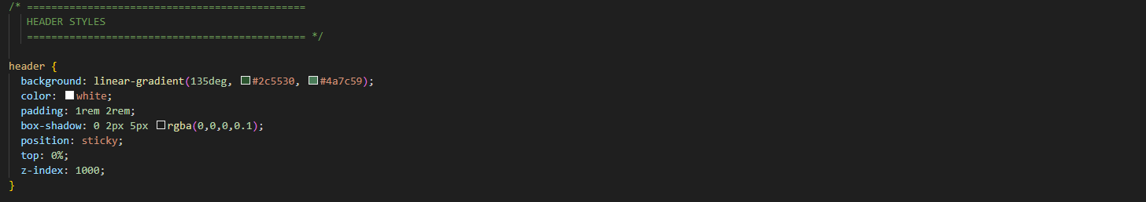

|  |  |
| --- | --- |
| No. | Description |
| 1. | Sticky navigation bar   * header contains the sticky navigation bar for the site. * position: sticky and top: 0 keep it fixed while scrolling. * z-index: 1000 ensures the header stays above all other elements. |

## Hover effect

The hover effect lifts the element when hovered upon, giving an engaging outlook, improving user experience. The elements also have some shadow to add subtle depth to the hover effect.

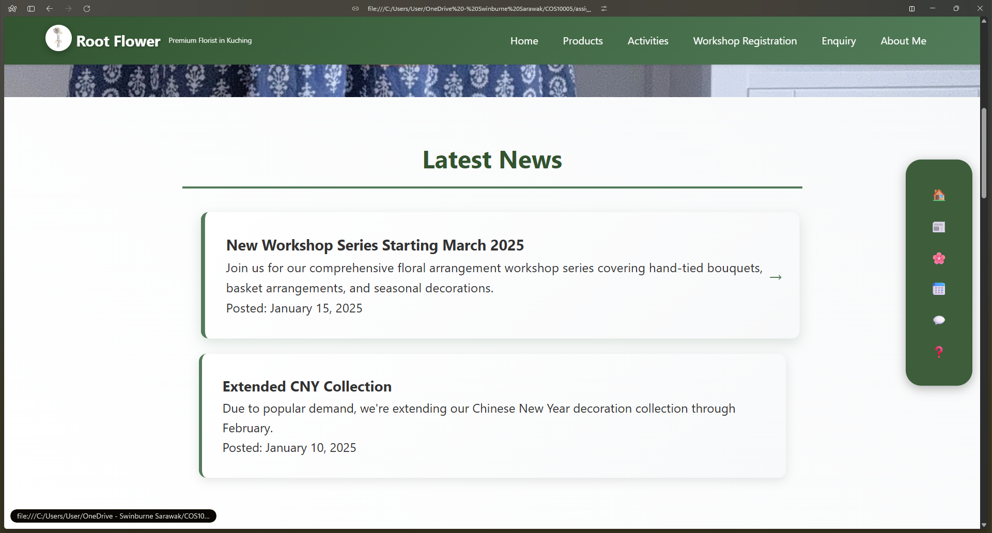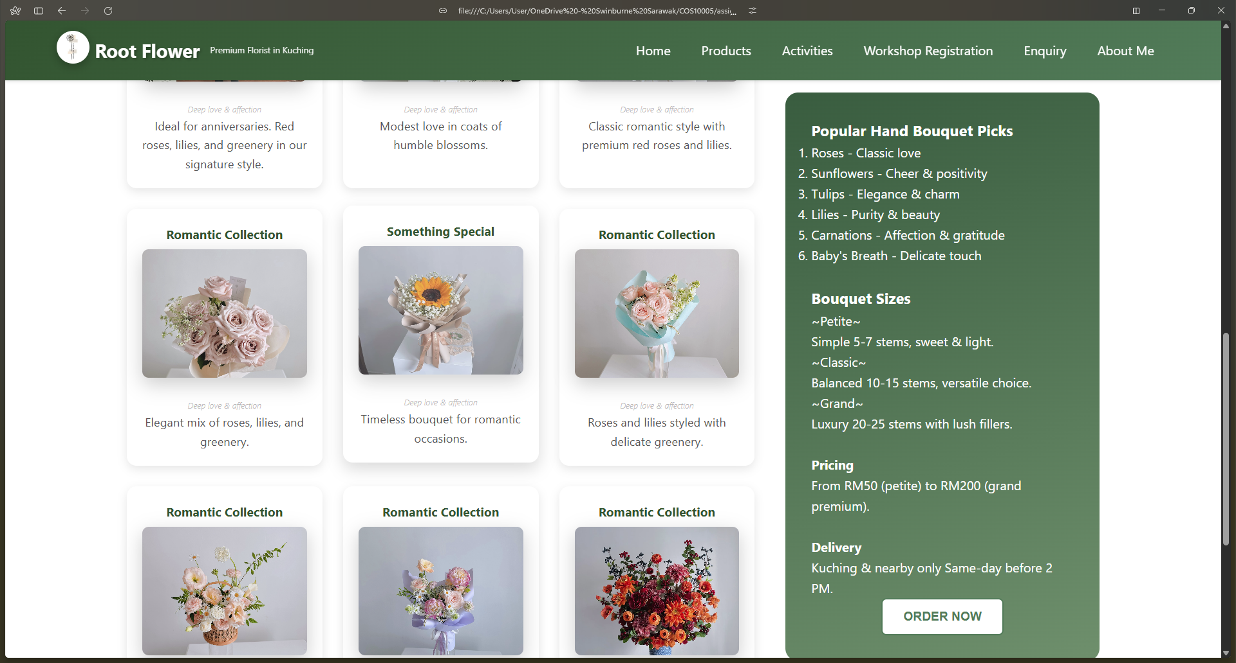

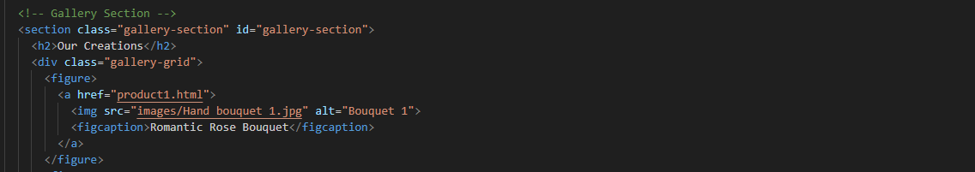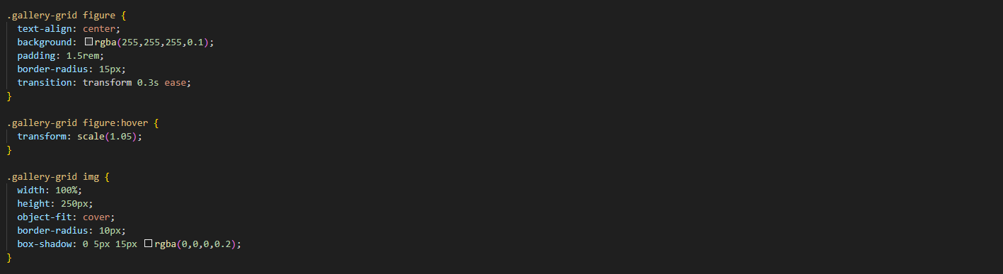

2

1

|  |  |
| --- | --- |
| No. | Description |
| 1 | HTML section   * The gallery is built inside a <section> with the class gallery-section. * Within it, a <div> with the class gallery-grid holds multiple <figure> elements. * Each <figure> contains a clickable link (<a href="product1.html">) that wraps an image and a <figcaption>. |
| 2 | CSS hover effect   * Each .gallery-grid figure has centred text, a soft translucent background, rounded corners, and internal padding for balance. * A transition (transform 0.3s ease) ensures smooth hover animations. * When hovered, .gallery-grid figure:hover scales slightly larger (scale(1.05)), creating a zoom-in effect that highlights interactivity. * Images inside .gallery-grid img fill the container width, have a fixed height of 250px, and use object-fit: cover to avoid distortion. * They include gentle rounded corners and a subtle shadow for visual depth. |

## Lightbox image

The lightbox mechanism allows the image to enlarge to the full screen when clicked on, allowing users to view the product more comprehensively, while improving user’s experience. To close the lightbox, users just click the close button (x) on the top right and the image will retract back.

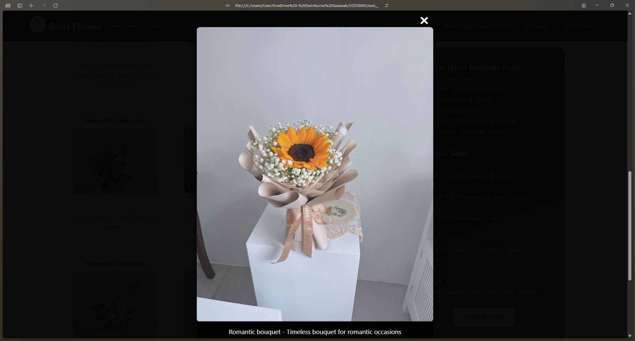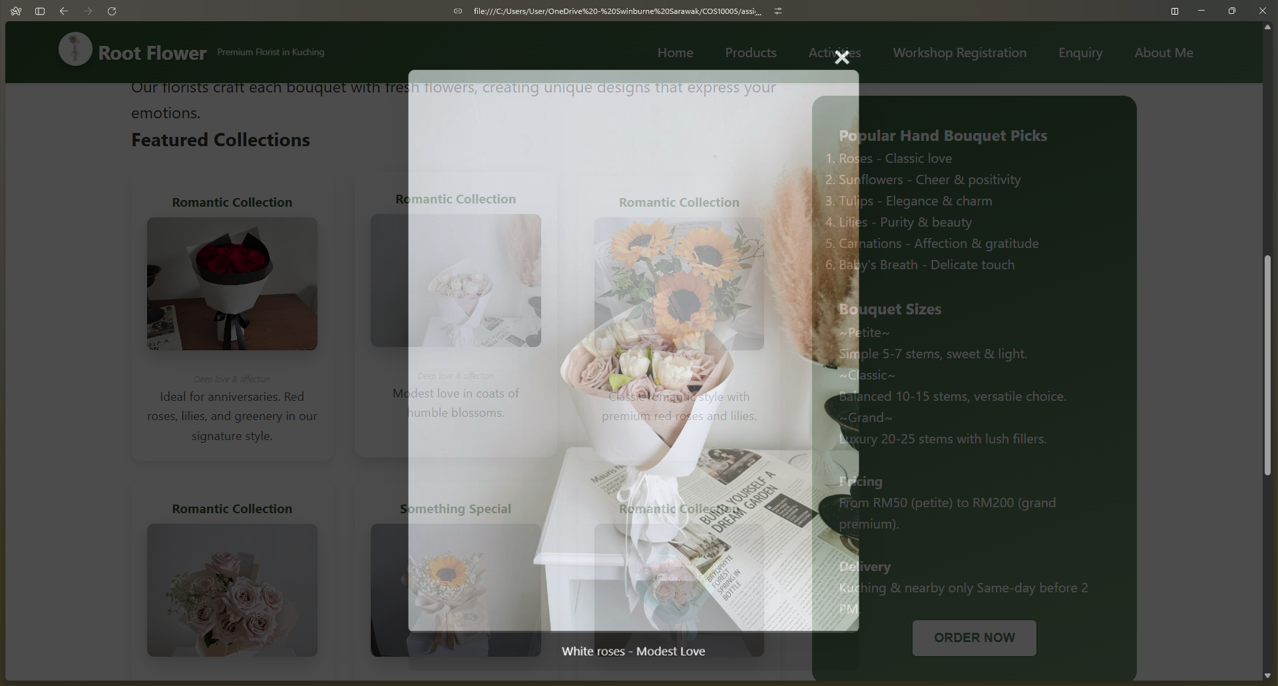

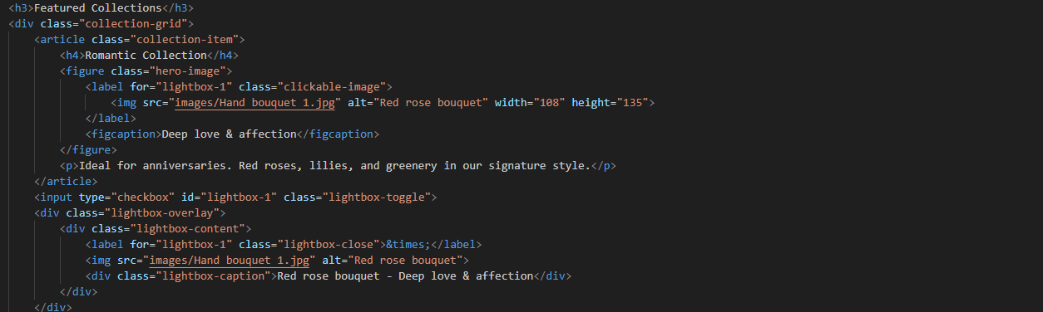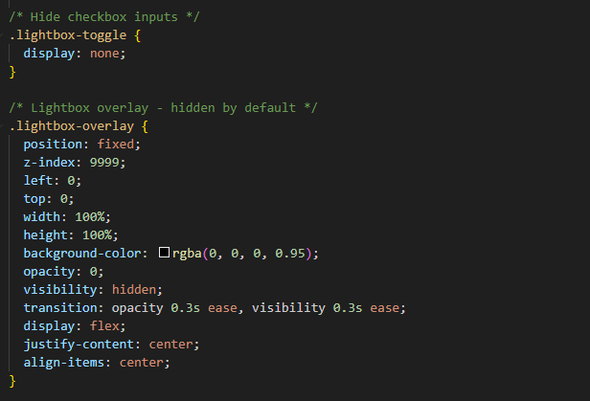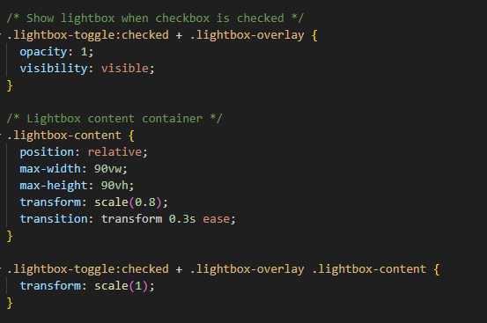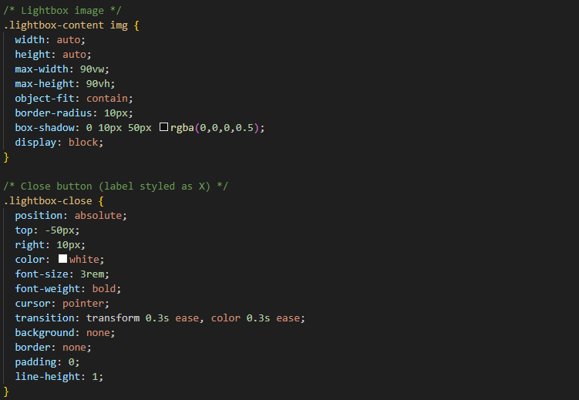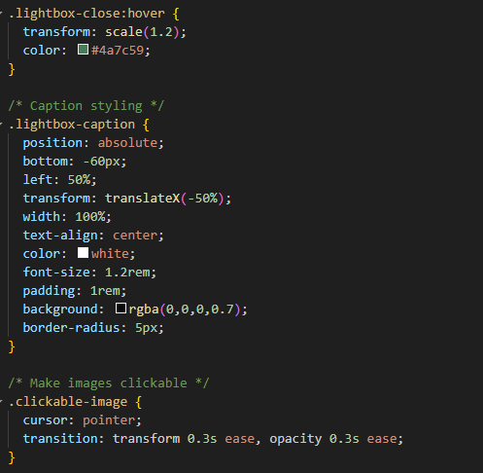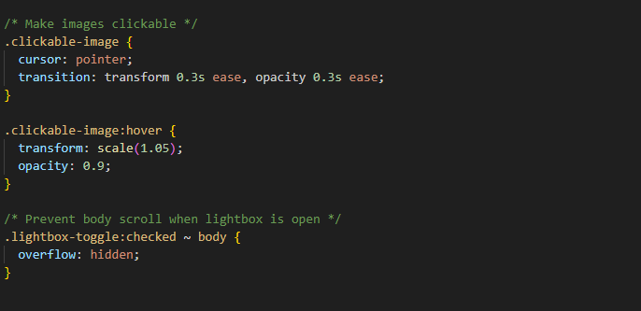

5

3

4

4

3

3

2

2

1

|  |  |
| --- | --- |
| No. | Description |
| 1 | HTML section   * lightbox-toggle is a hidden checkbox controlling lightbox visibility. * When checked, lightbox-overlay appears as a full screen dark background. |
| 2 | CSS Lightbox transition   * lightbox-toggle is hidden using display: none for logical switching. * lightbox-overlay covers entire screen with position: fixed and full width. * It uses semi-transparent black background (rgba(0,0,0,0.8)) and z-index: 9999. * Initially hidden with opacity: 0 and visibility: hidden. * Activated via checkbox, fades in with smooth opacity and visibility transition. |
| 3 | Lightbox content   * lightbox-content contains enlarged image and optional caption. * Image scales responsively using max-width: 90vw and max-height: 90vh. * Rounded corners and soft shadows give the image refined appearance. * lightbox-caption below image shows descriptive text on semi-transparent background. |
| 4 | Close lightbox   * lightbox-close is a label button with “×” to close lightbox. * Linked to the checkbox input to toggle lightbox visibility. * Positioned top-right with hover effects: scale and colour shifts. |
| 5 | Clickable image   * Thumbnails link to the hidden checkbox via label-target relationship. * On hover, thumbnails slightly enlarge and dim for feedback. * Connects images to lightbox, enabling JavaScript-free pop-up display. |

## Flippable cards

The flappable cards when hovered upon will show be flipped 180 degrees to the other side, showcasing more details regarding the element in front of the card. This not only allows engaging user experience, but also saes space for the webpage, allowing a cleaner outlook.

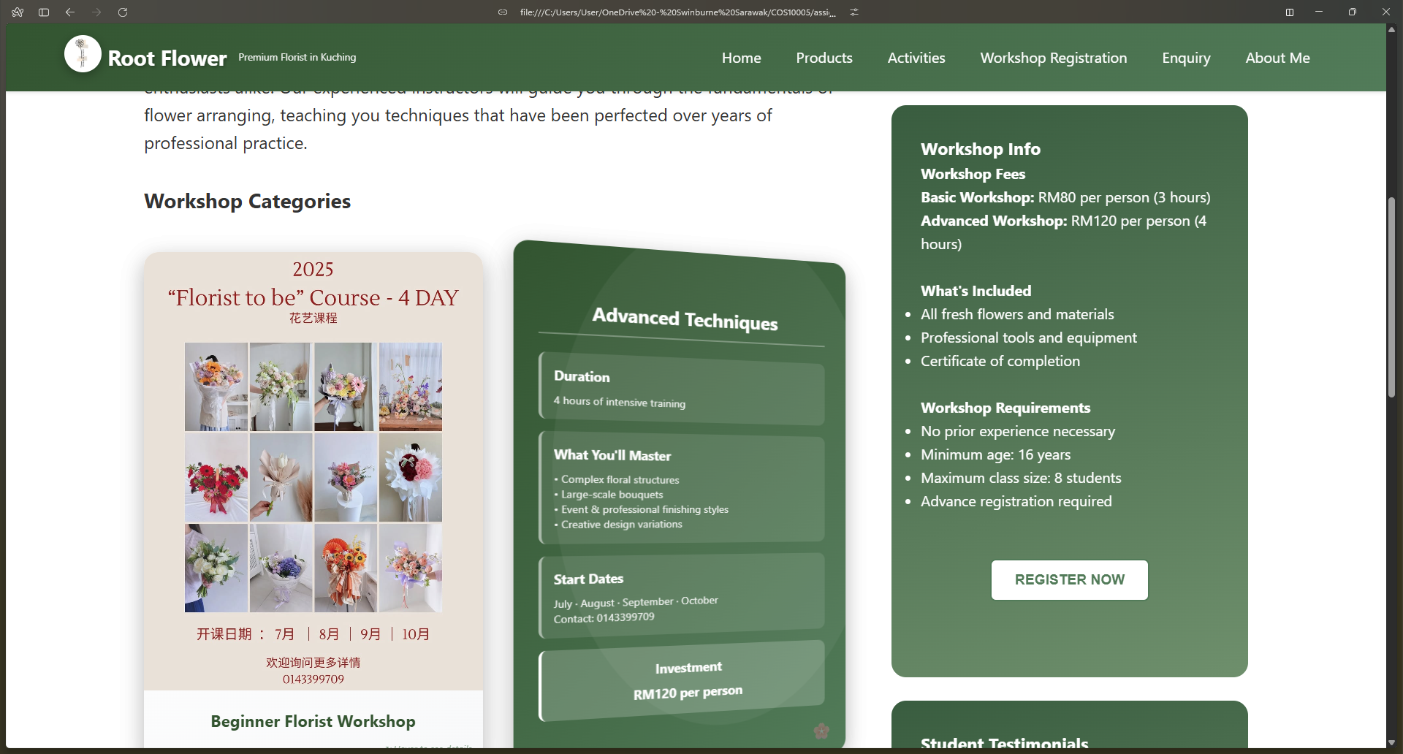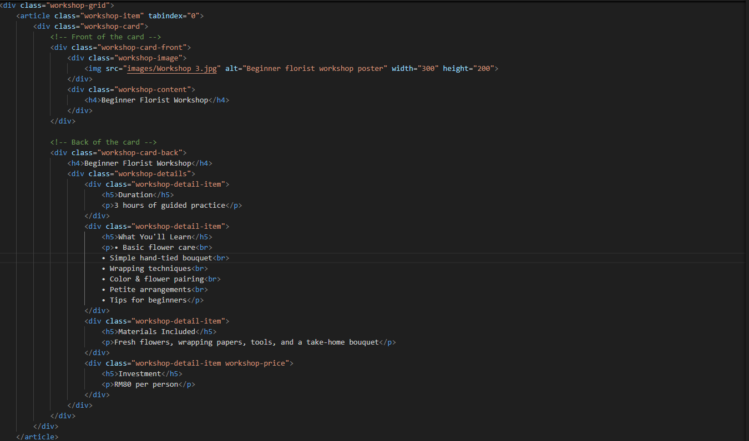

1

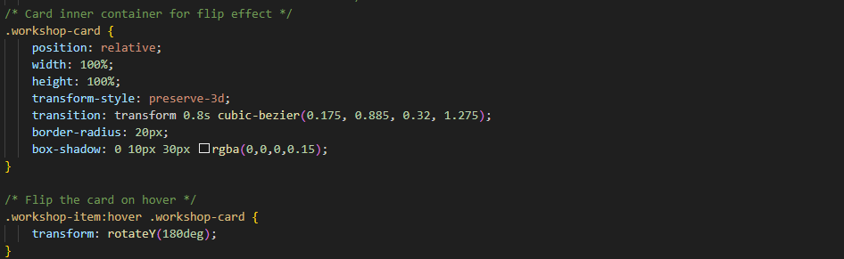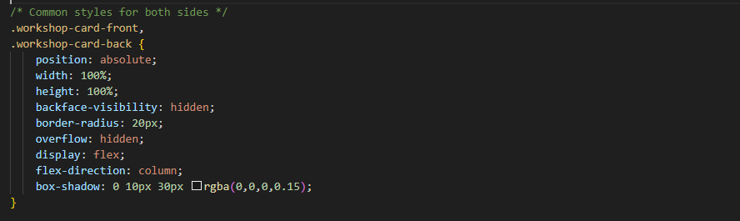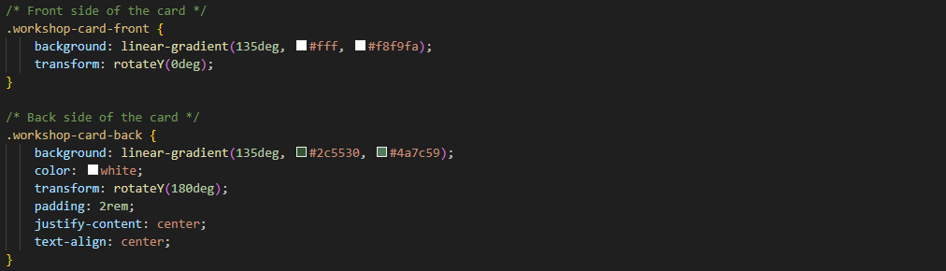

4

4

3

2

|  |  |
| --- | --- |
| No. | Description |
| 1 | HTML section   * workshop-grid arranges flip cards in a responsive grid layout. * workshop-item wraps a card and supports keyboard focus (tabindex="0"). * workshop-card contains front and back sides for flipping interaction. * Front shows visuals or title; back shows details and pricing info. |
| 2 | 3D structure and Flip animation   * Uses transform-style: preserve-3d for shared 3D card space. * Transition with cubic-bezier curve creates smooth elastic flip motion. * Rounded corners (20px) and subtle shadow add depth effect. |
| 3 | Flipping trigger mechanism   * On hover, workshop-card rotates 180deg around the Y-axis. * Front and back share size and absolute positioning for alignment. * Back side appears while front side flips away smoothly. |
| 4 | Workshop card front & back design   * Front and back use absolute positioning, full width and height, and flex layout. * Front side has a light gradient and stays visible by default. * Back side uses dark green gradient, white text, and rotates 180deg on flip. * Padding and centred alignment keep content balanced and readable. |

## Responsive hamburger menu

The responsive hamburger menu only shows when the screen size is less than 968 px. The responsive burger menu essentially hides the bulky navigation bar from mobile users, allowing the mobile users to expand the navigation bar to access the links to different webpages only when needed.

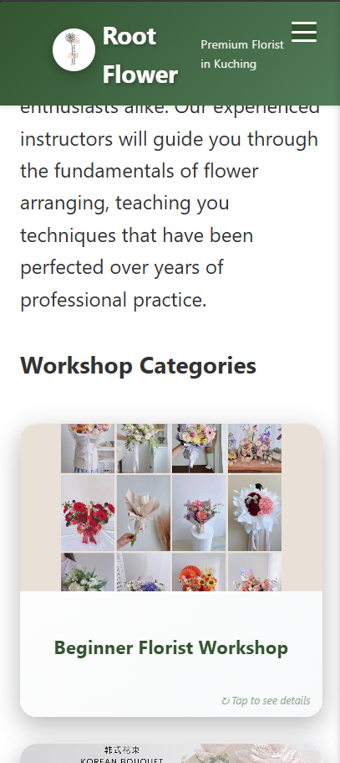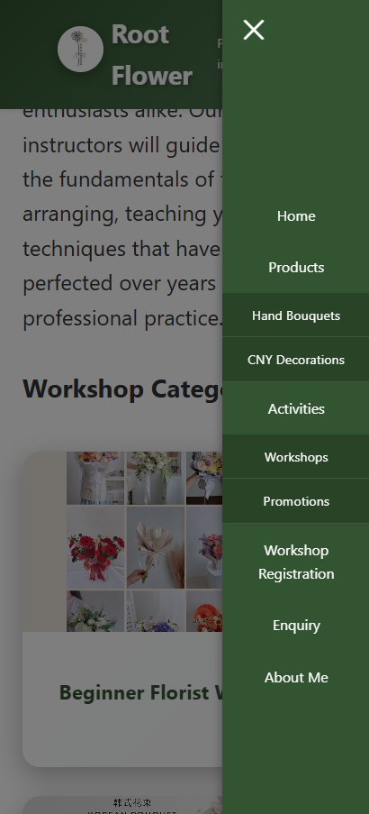

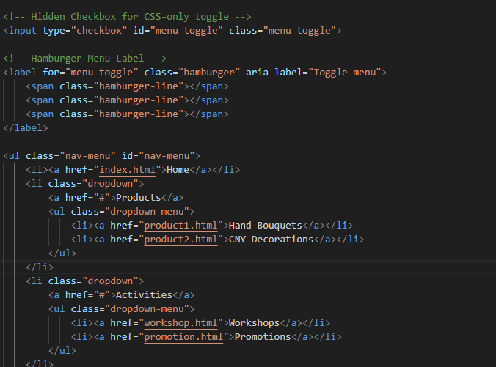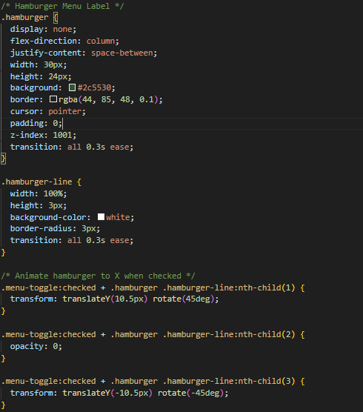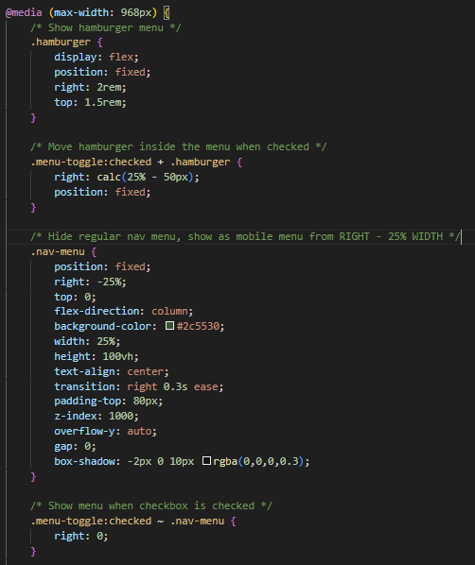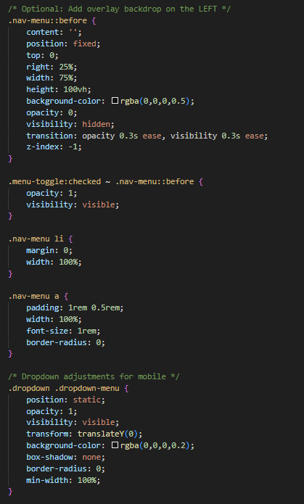

4

3

3

2

1

|  |  |
| --- | --- |
| No. | Description |
| 1 | HTML section   * nav contains logo, title, and tagline inside logo-container. * Hidden checkbox (#menu-toggle) controls mobile menu visibility. * label linked to checkbox forms hamburger icon with three <span> lines. * Clicking label toggles checkbox, showing or hiding .nav-menu links. * Links display horizontally on desktop and slide out on mobile. |
| 2 | CSS hamburger appearance   * hamburger styles the mobile toggle button, hidden on large screens. * Three hamburger-line bars are white, rounded, on dark green background. * Transitions create smooth animation between open and closed states. |
| 3 | CSS hamburger transformation   * Activating #menu-toggle animates the hamburger into a close “X” shape. * The first line rotates 45° and moves downward. * The second line fades out with opacity: 0. * The third line rotates -45° and moves upward. * All transformations use only CSS for interactive effects. |
| 4 | Mobile CSS   * @media (max-width: 968px) adjusts navigation for smaller screens. * The hamburger icon appears, fixed at top-right corner. * nav-menu switches to a vertical sliding panel from the right. * Initially off-screen (right: -25%), it slides in when checked. * Panel uses dark green background, white text, full viewport height. * Semi-transparent overlay fades in behind panel to dim background. |

# Conclusion

## Summary of Report

The report encompasses the content, and HTML and CSS technical review of the website Root Flower. Besides that, enhancements were added to the website to allow more convenient, engaging and interactive user experience. In short, the website succeeds in delivering the content while maintaining aesthetic visual appearance, making it a decent website.

## Future Recommendation

Since the website only utilises pure CSS stylings, the code pile can be enormous and leading to harder maintenance as the size grows. To overcome this, JavaScript should be used in the future, which can enable more interactive elements in the website with less code, elevating the user experience. Besides that, the information of the website can be further added with more information digging or maybe even interview with the Root Flower’s owner.

# References

Flippable card using pure CSS

<https://codepen.io/edeesims/pen/wvpYWW>

Pure CSS lightbox

<https://codepen.io/gschier/pen/kyRXVx>

Pure CSS hamburger fold-out menu

<https://codepen.io/erikterwan/pen/EVzeRP>

CSS dropdown menu

<https://www.w3schools.com/css/css_dropdowns.asp>

CSS hover effect

<https://www.w3schools.com/cssref/sel_hover.php>